

[placeholder]

This is the EtherGem (EGEM) Guide to the Opal Wallet version Alpha 0.0.1

1. Grab the zip file and unzip in a high level folder, something like “C:\Egem5\<unzipped>
2. You will go into that folder and double click the “Opal-Alpha-1.0.1.exe” and then it will run and you will have to accept one or two network authorizations that look like the one shown.

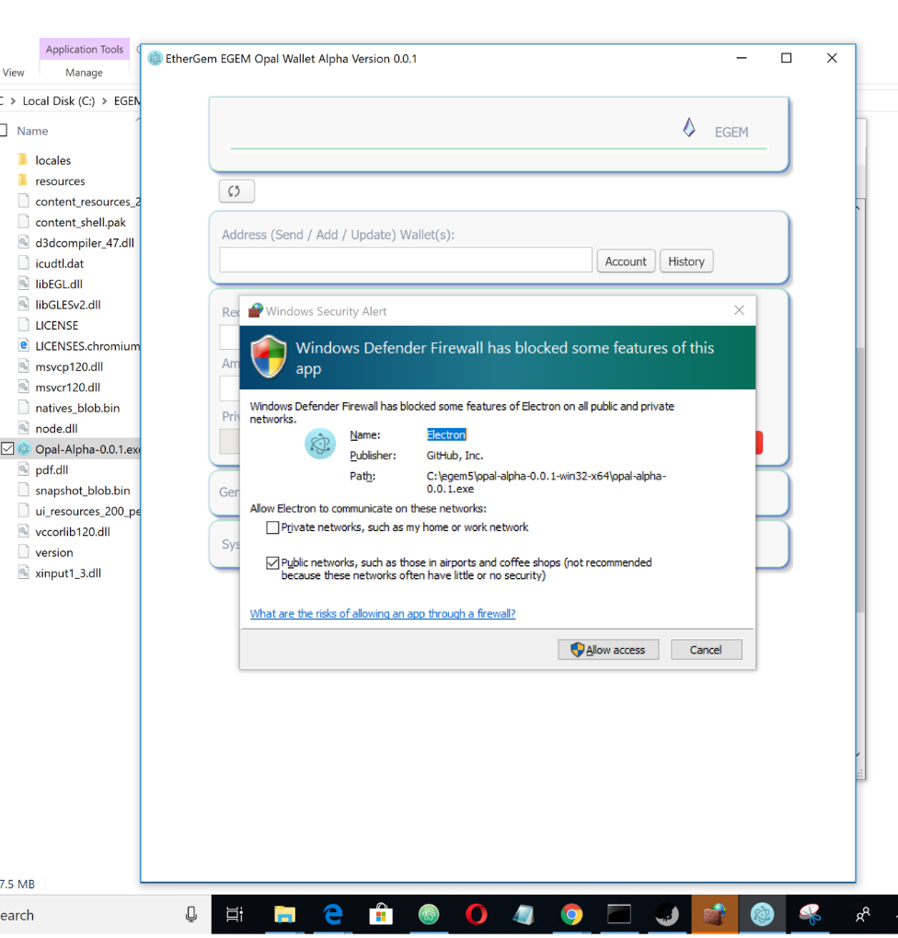

1. The first thing you will see is a blank app. Add wallets to the Address line and click “Account” to load them above into your wallet store.

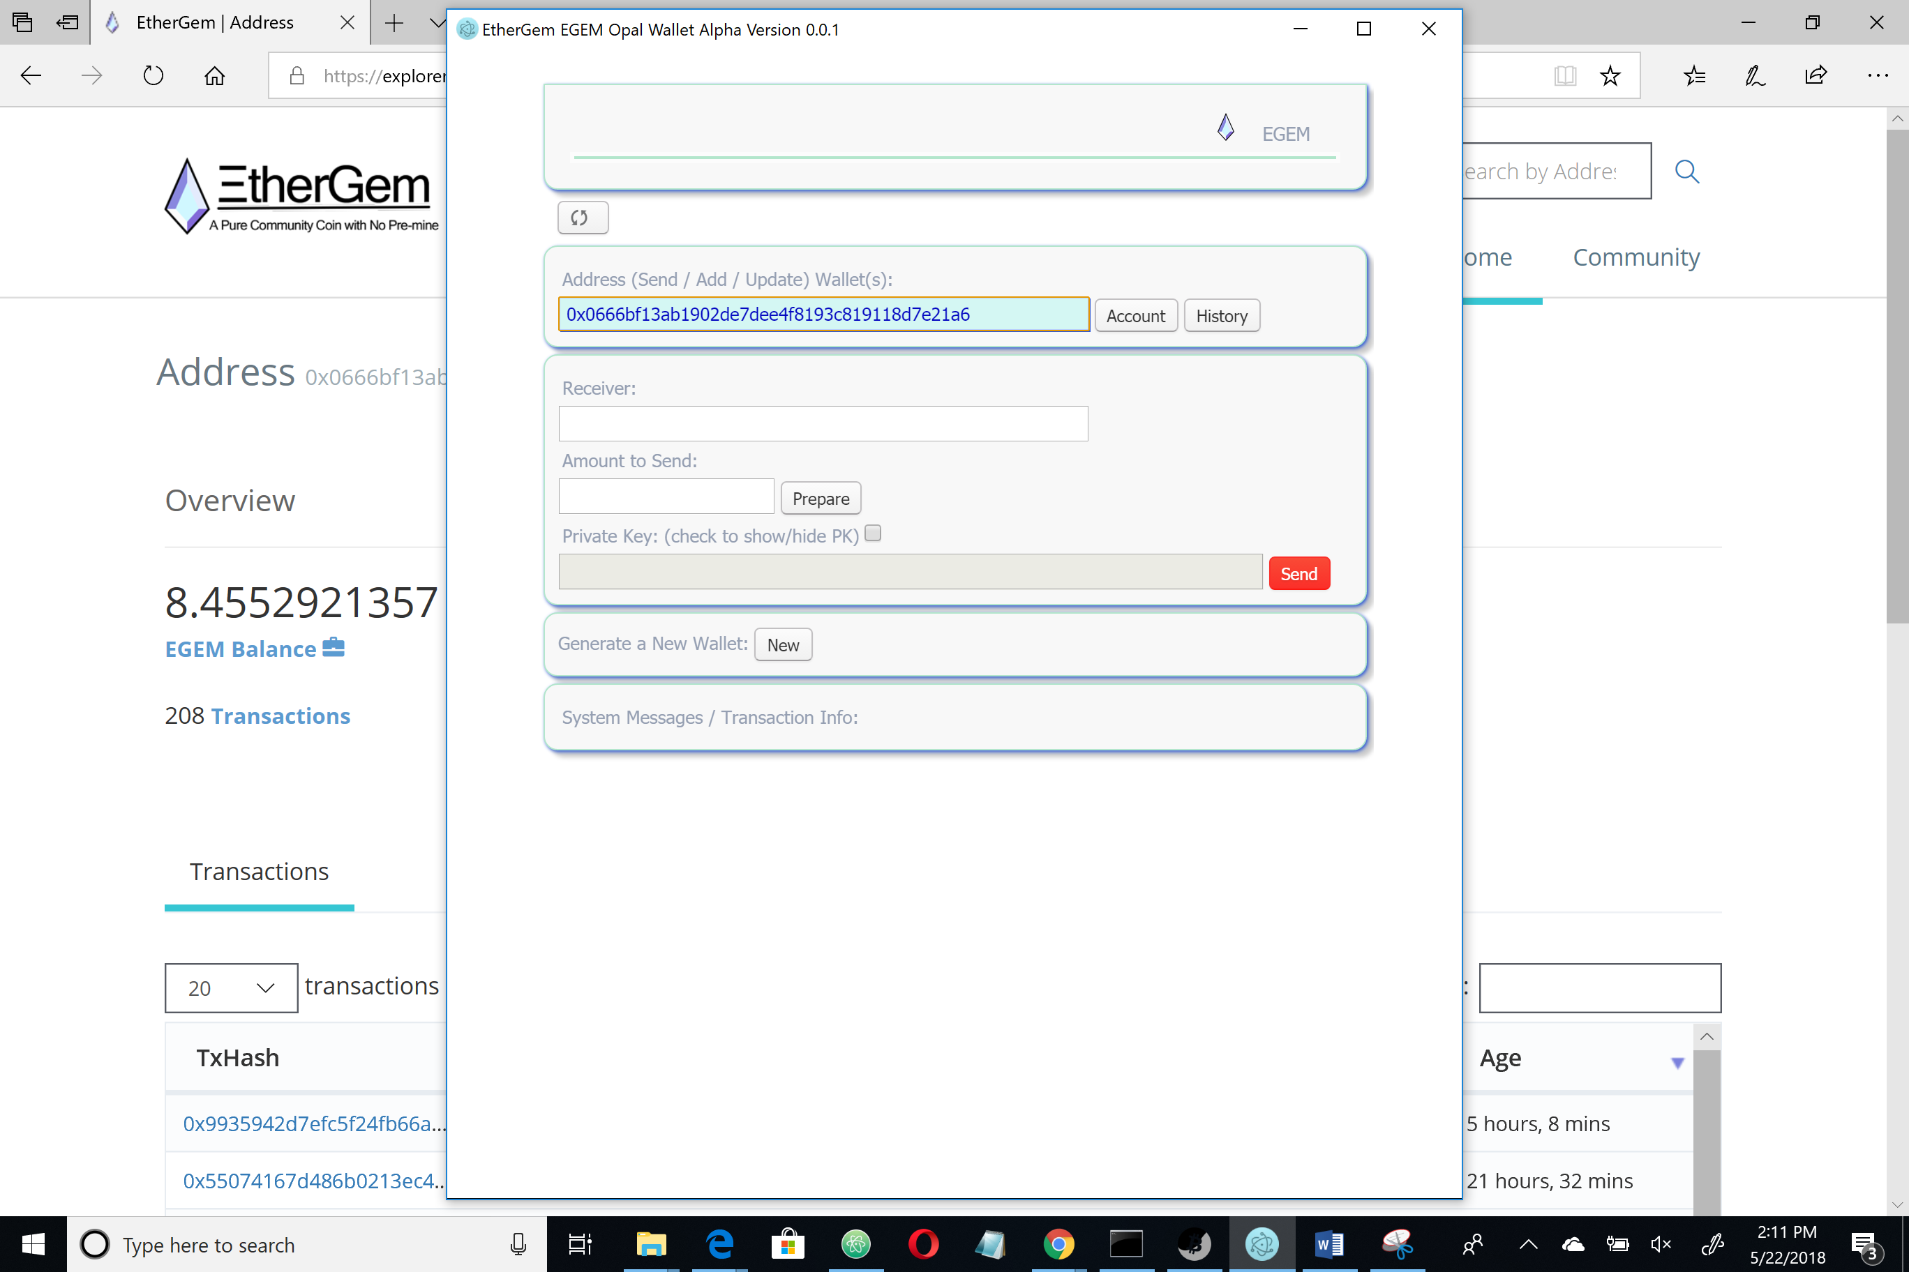

1. When you add a wallet or if you click one from the sotre it will fire off a message showing the current balance and letting you know it is successfully added. This highlighted (yellow) area is the system message display and you will see it fire off frequently for different actions. You should read those messages as many of them relate to the actions you are performing on your wallets.

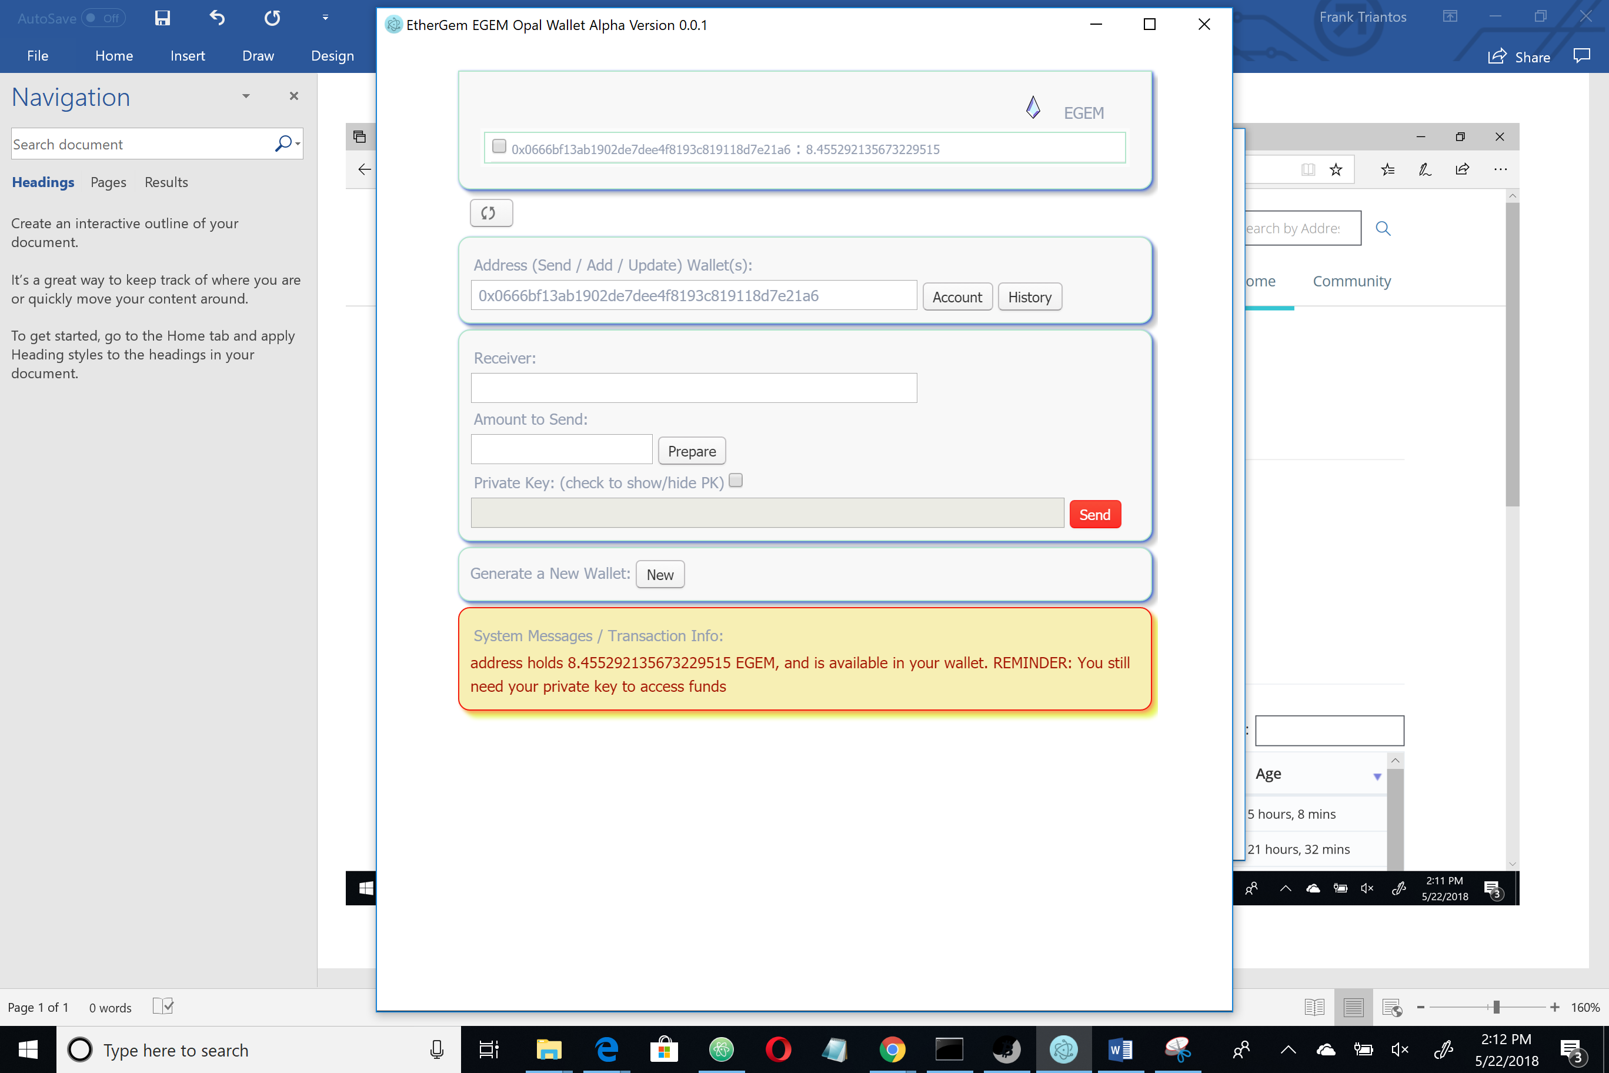

1. You can add EGEM account addresses to your store by generating them in the Opal Wallet as well. When you click “Generate a New Wallet” You will be presented with a PDF to save. If you do not pay attention, this is going to save in the appdata folder and you may have trouble locating it. It would be better for you to direct this file to save in a location you trust and can remember. It is highly likely that the next address you generate, the file location you navigate to will be queued up.

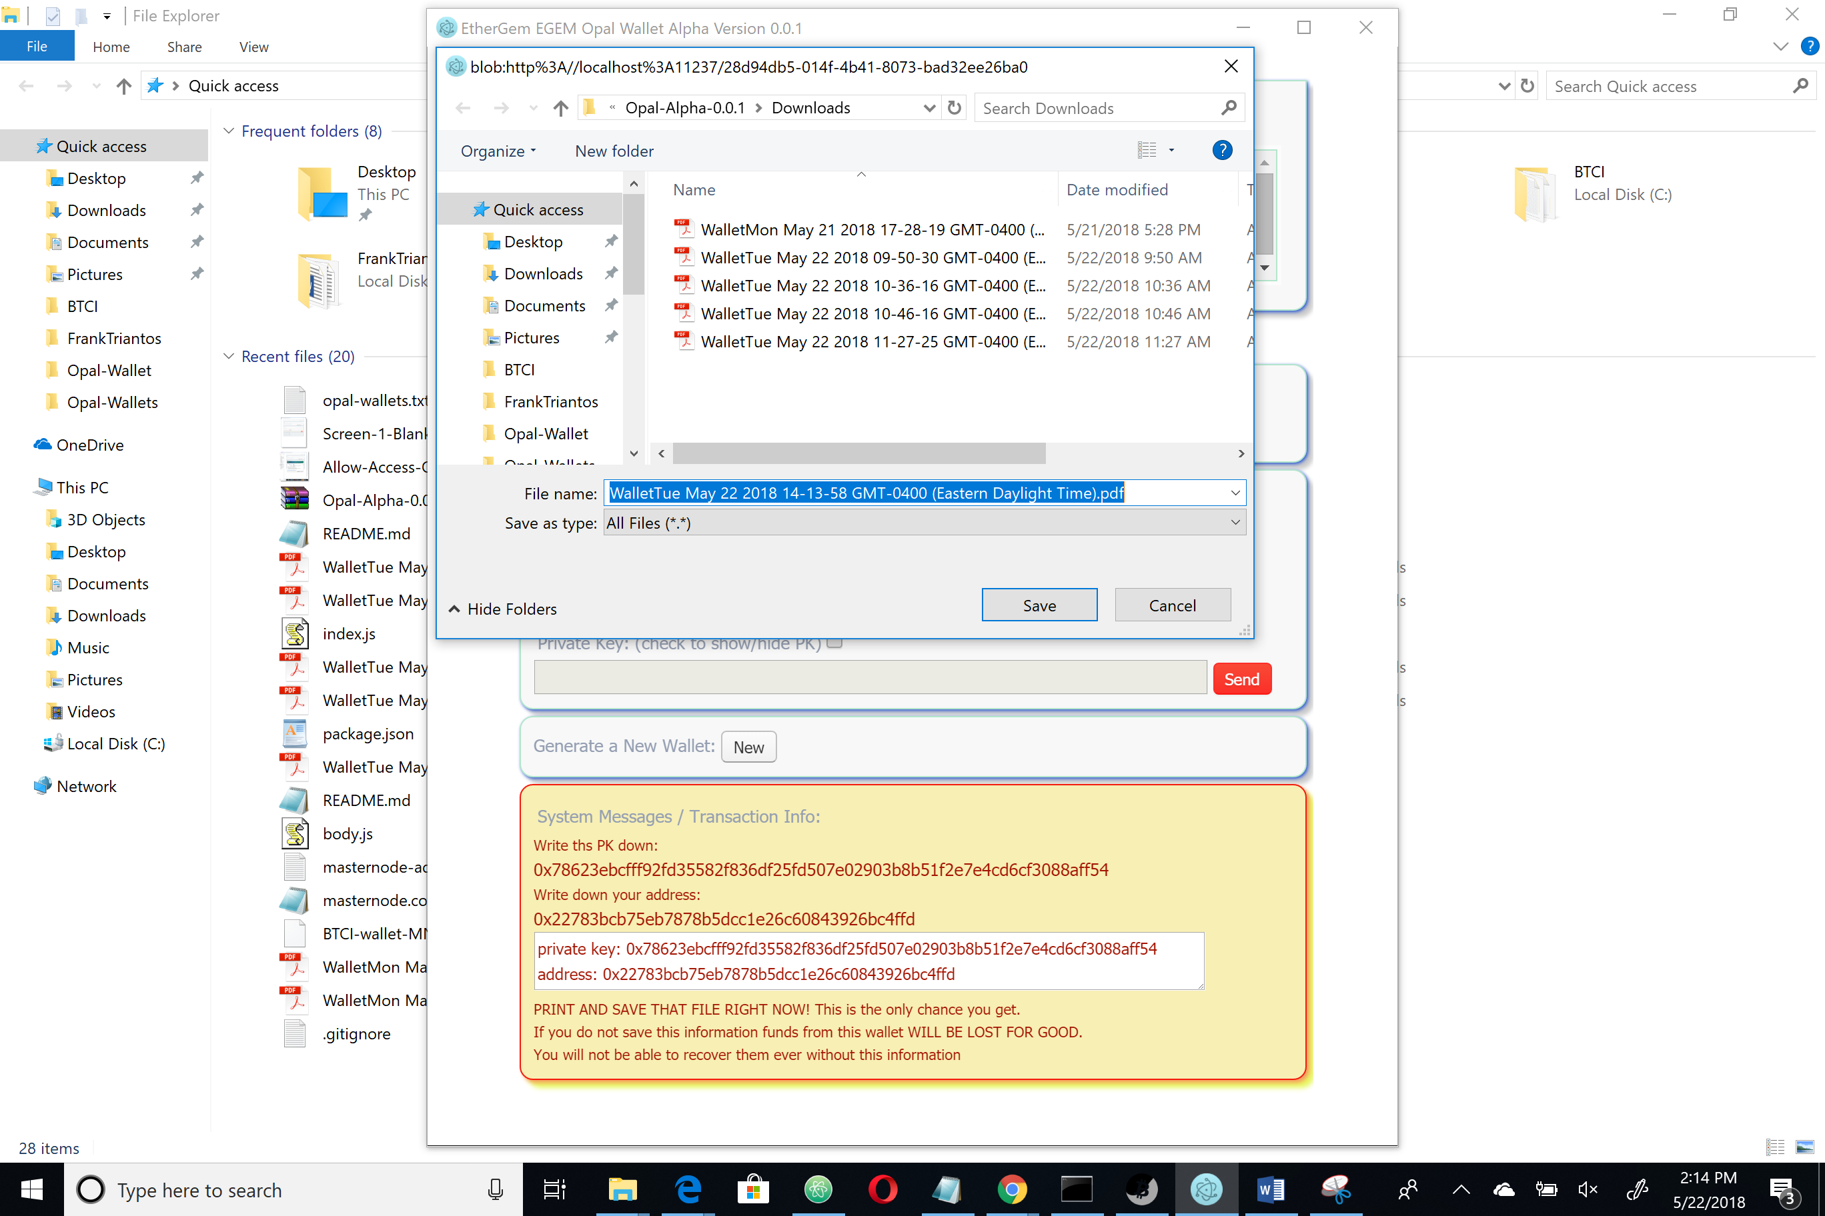

The next couple screens just show us also copying the text displayed for you on the application and saving a second copy into a text file and also why that is important. A real crypto OG is super sensitive to keeping their PK and address information offline. You definitely want to be a real crypto OG, right? Then act like one.

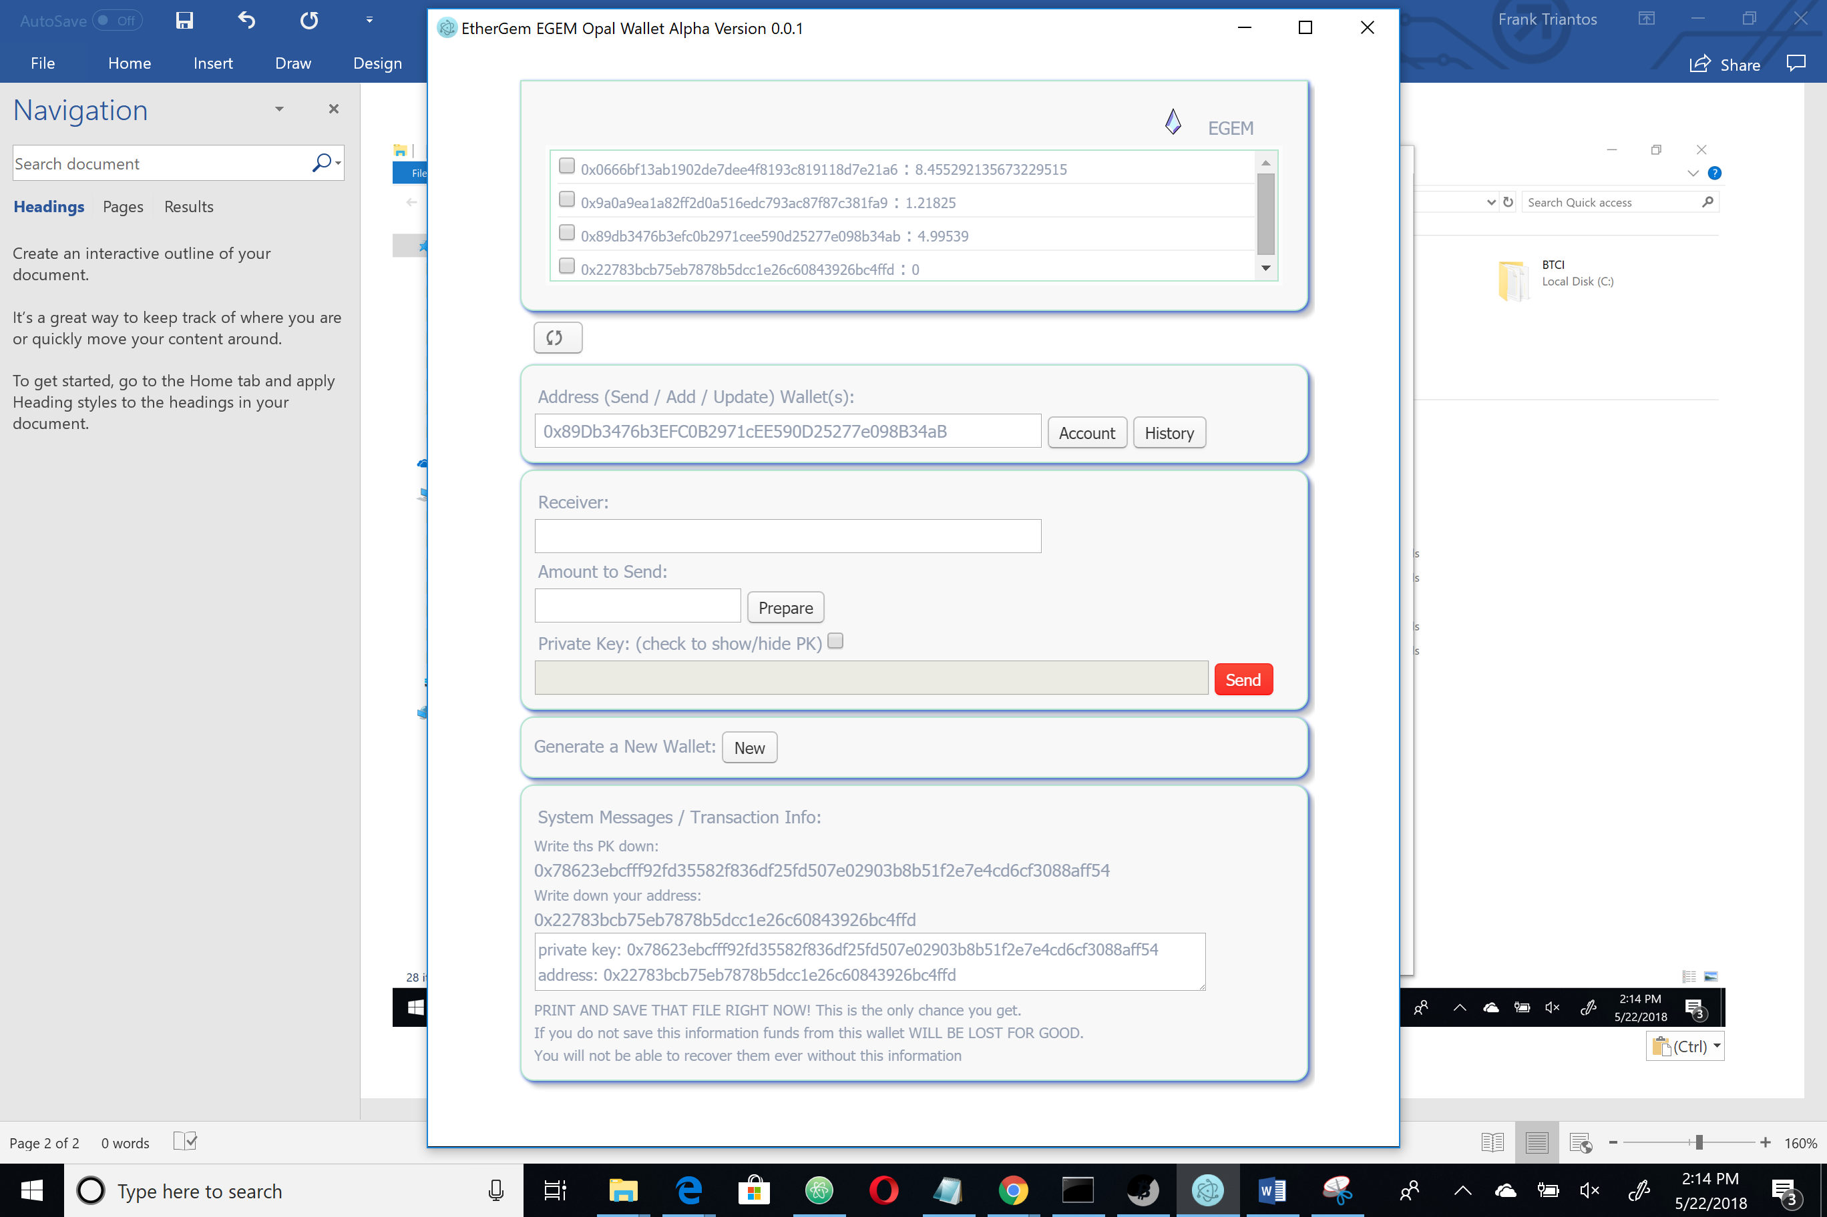

You will also want to copy and paste the private key and address and save them in a test file (notepad is good for this). You now have two copies of your wallet. You will need to save the private key for later. It is recommended that you save these two files on a couple USB sticks and print out two copies and stick that whole bunch of data into an offline spot storage. You will want to be able to access one of the USB for when you need to transfer funds.

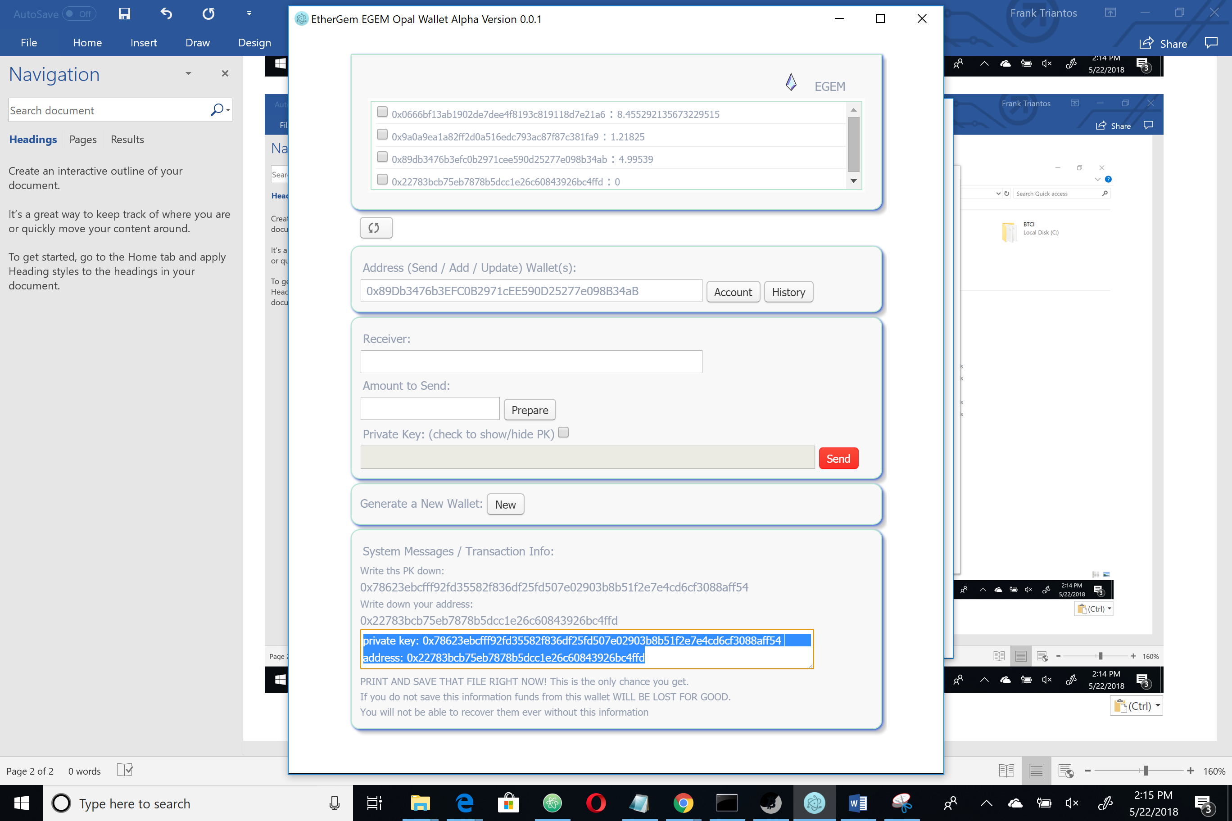

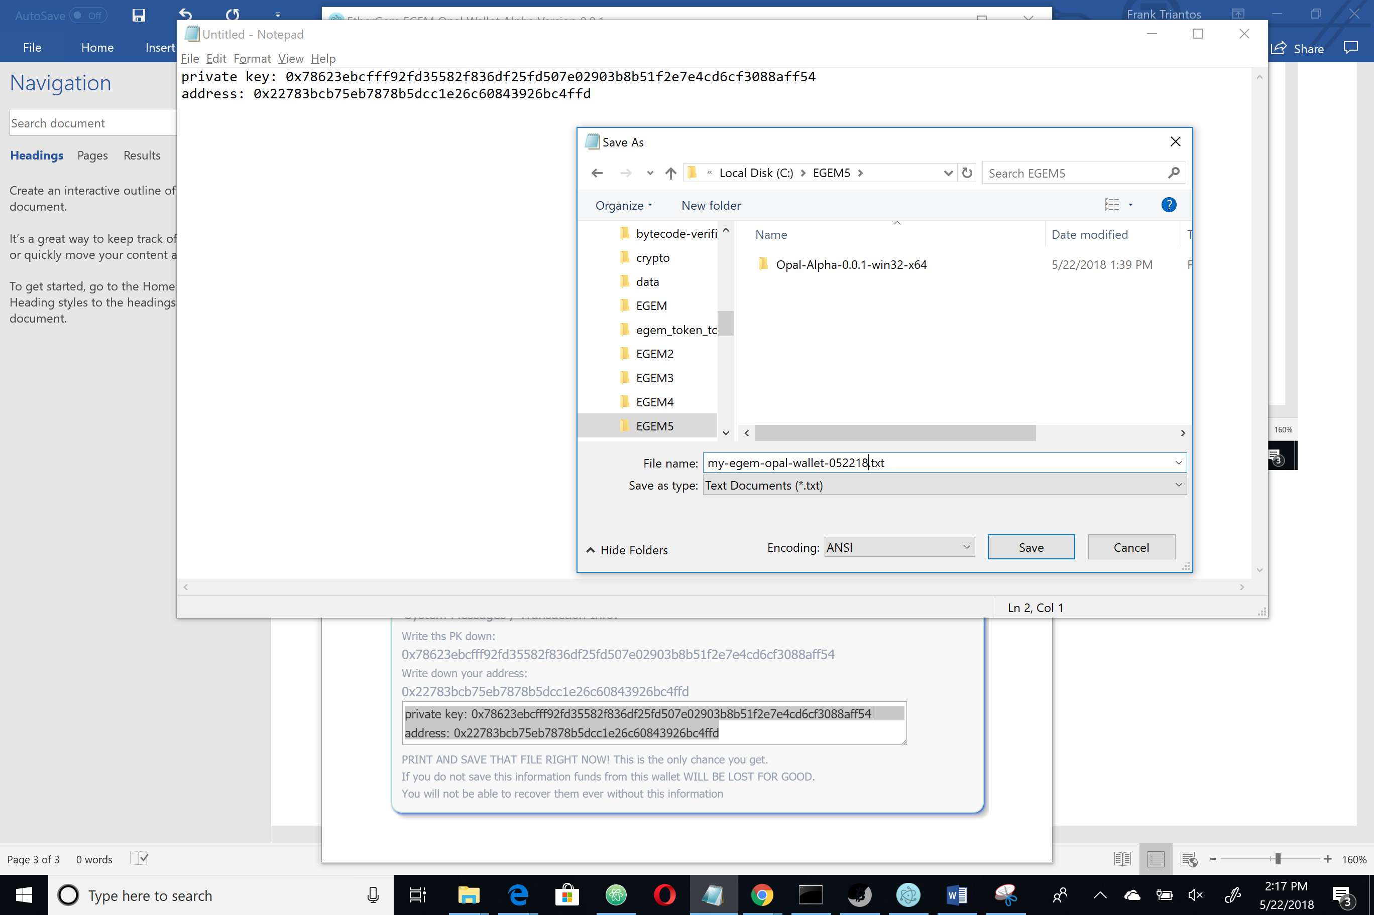

This is showing how we save the file. You should then immediately copy it onto a USB and store it offline. Most people don’t even keep their PK files on their working computer.

This next feature is a quirky function to grab updates from the chain and api pricing data. You click the double arrows and it sets you up with 10 30 second retrievals of data. At first the 10 will show up…

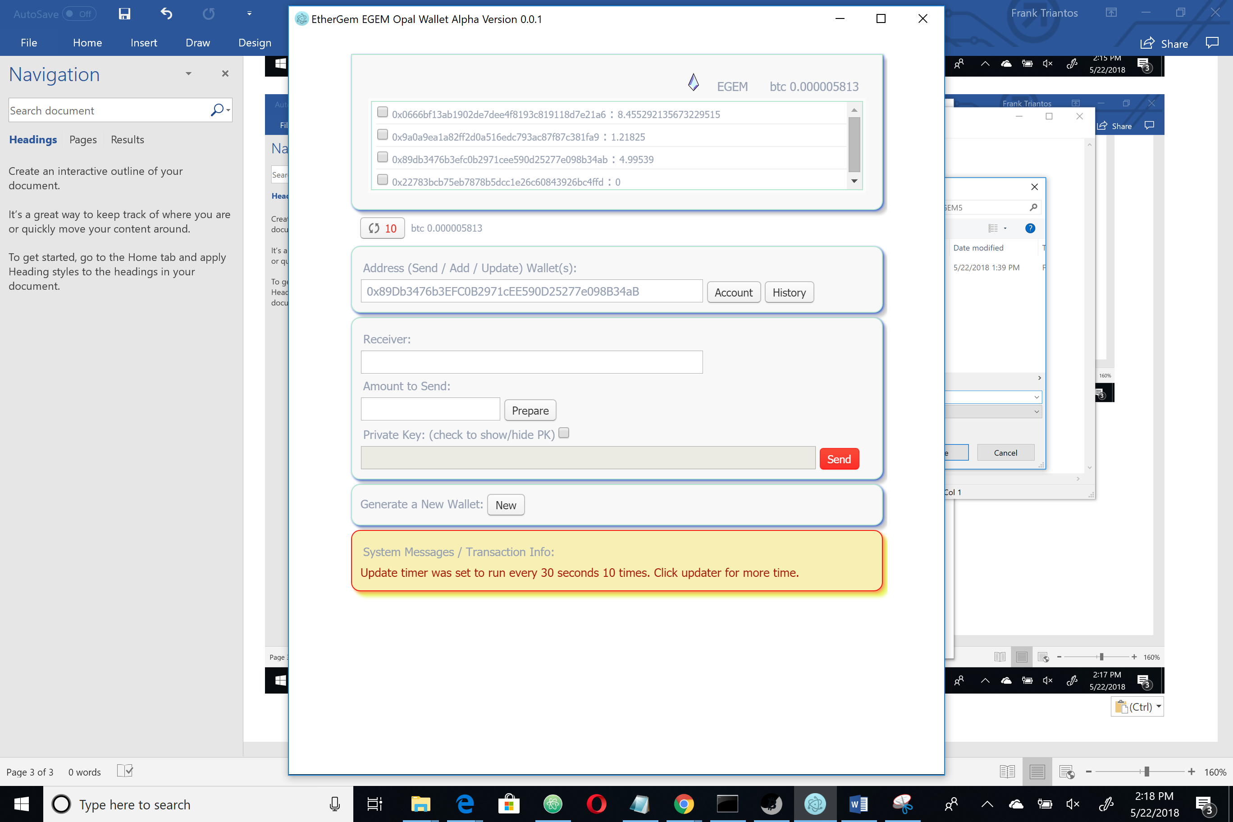

…and soon after the button will turn green and you will see 9 left. At this point you could increment that by 10 up to a point in case you just want to waste data time and call the api a lot. Usually 10 updates is plenty and you can redo this function when you begin looking at your wallet next use. Then your Egem Opal Wallet is not gonna just be running a lot of data calls all day without you using it.

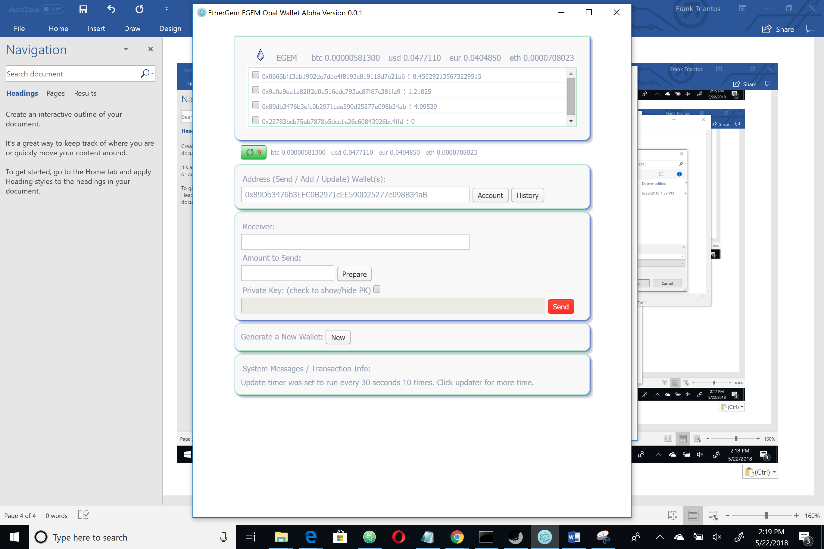

Keep going….

If you hover over an address in your store you will see the pricing update below the store (next to the timer button which is green in the following shop)

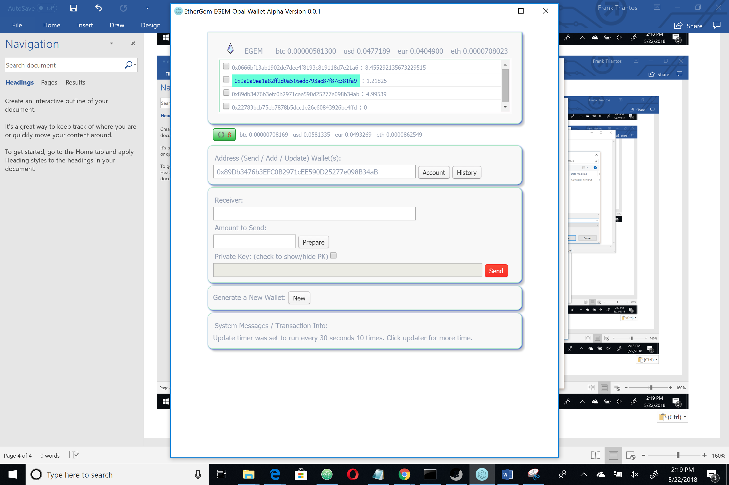

If you click on that address it will load in the address section and lock. This is how you can start a send transaction. In this case you would be sending EGEM from this address.

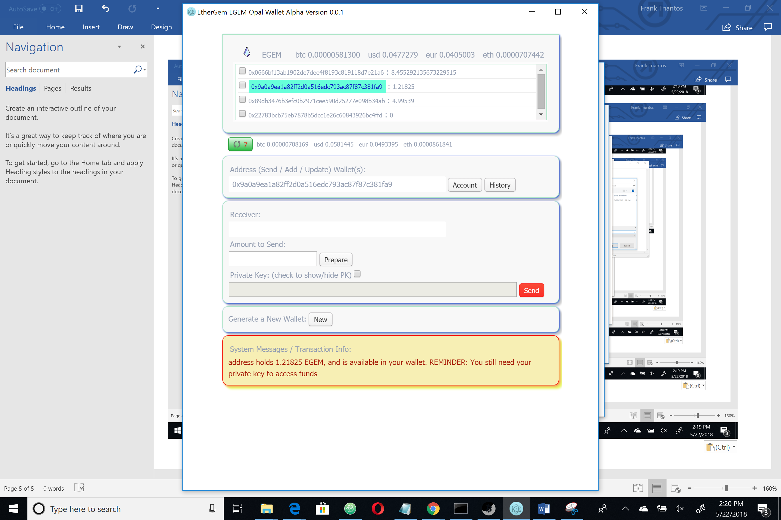

Now look at the lowest address in the store and notice it has 0 EGEM. This is the address we created earlier. I am gonna send it some EGEM…

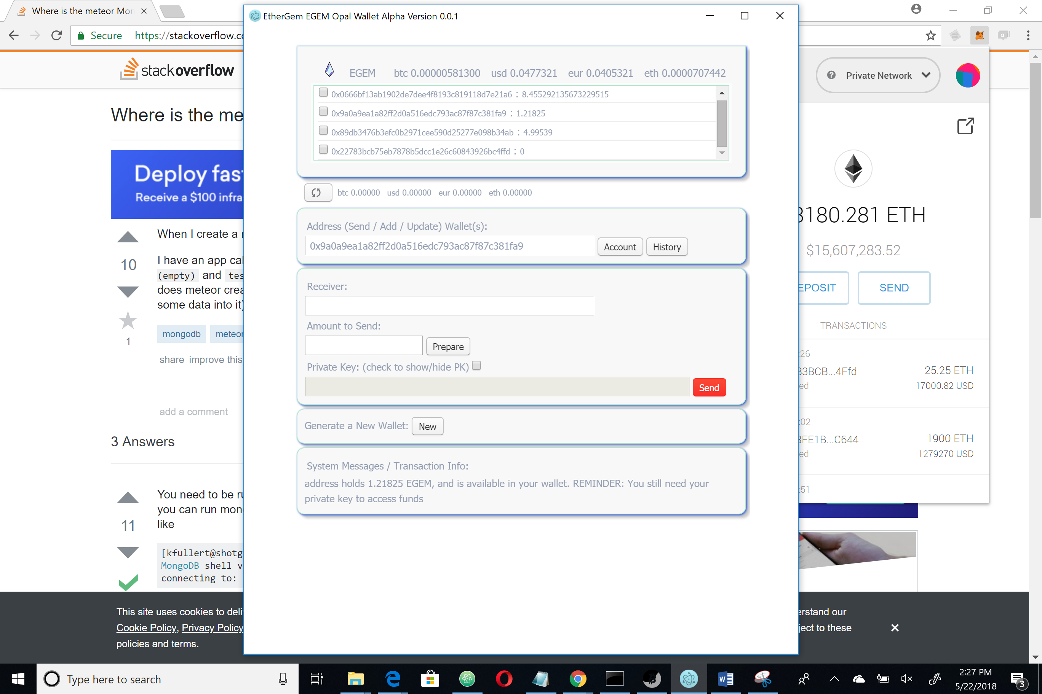

Now when we click it it updates with the new balance (or we could have had our timer set and it would update automatically, but in this case I just knew it would be there so I am updating it manually). We will use the timer to see the send in a few.

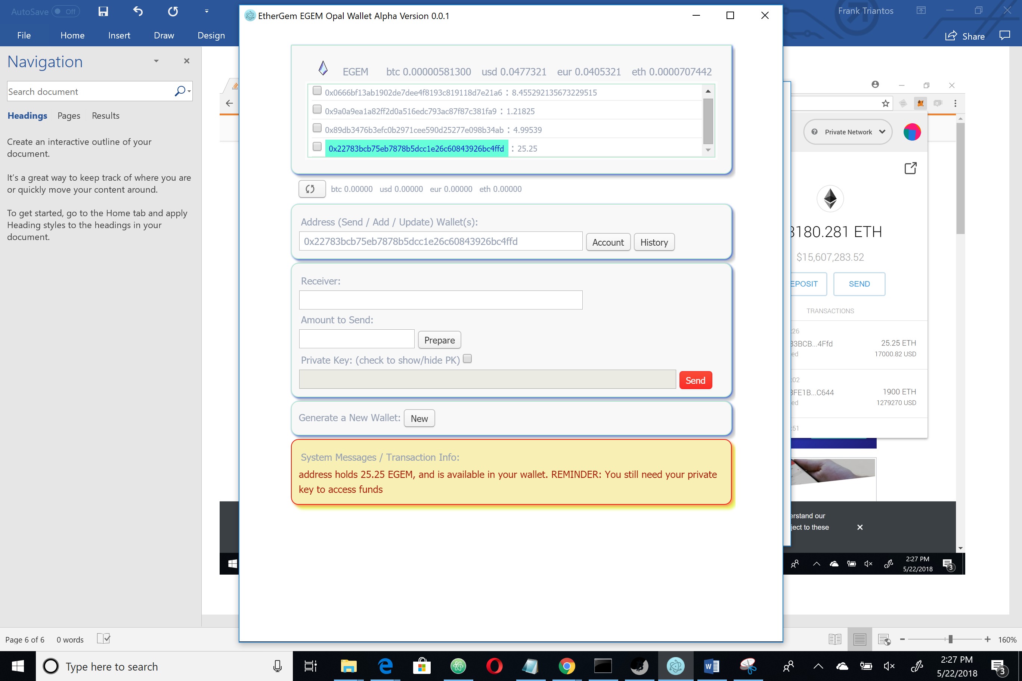

In fact, let’s turn on the timer in the next screen shot (and we have updated it a few times to 39 cycles of 30 seconds each. Like I said, this one is a quirky feature to make it fun. This function allows me as a dev to enhance this app and have some fun too. As a user you want to welcome that because it means very cool features down the road. So, I know its weird, but just enjoy it for now.

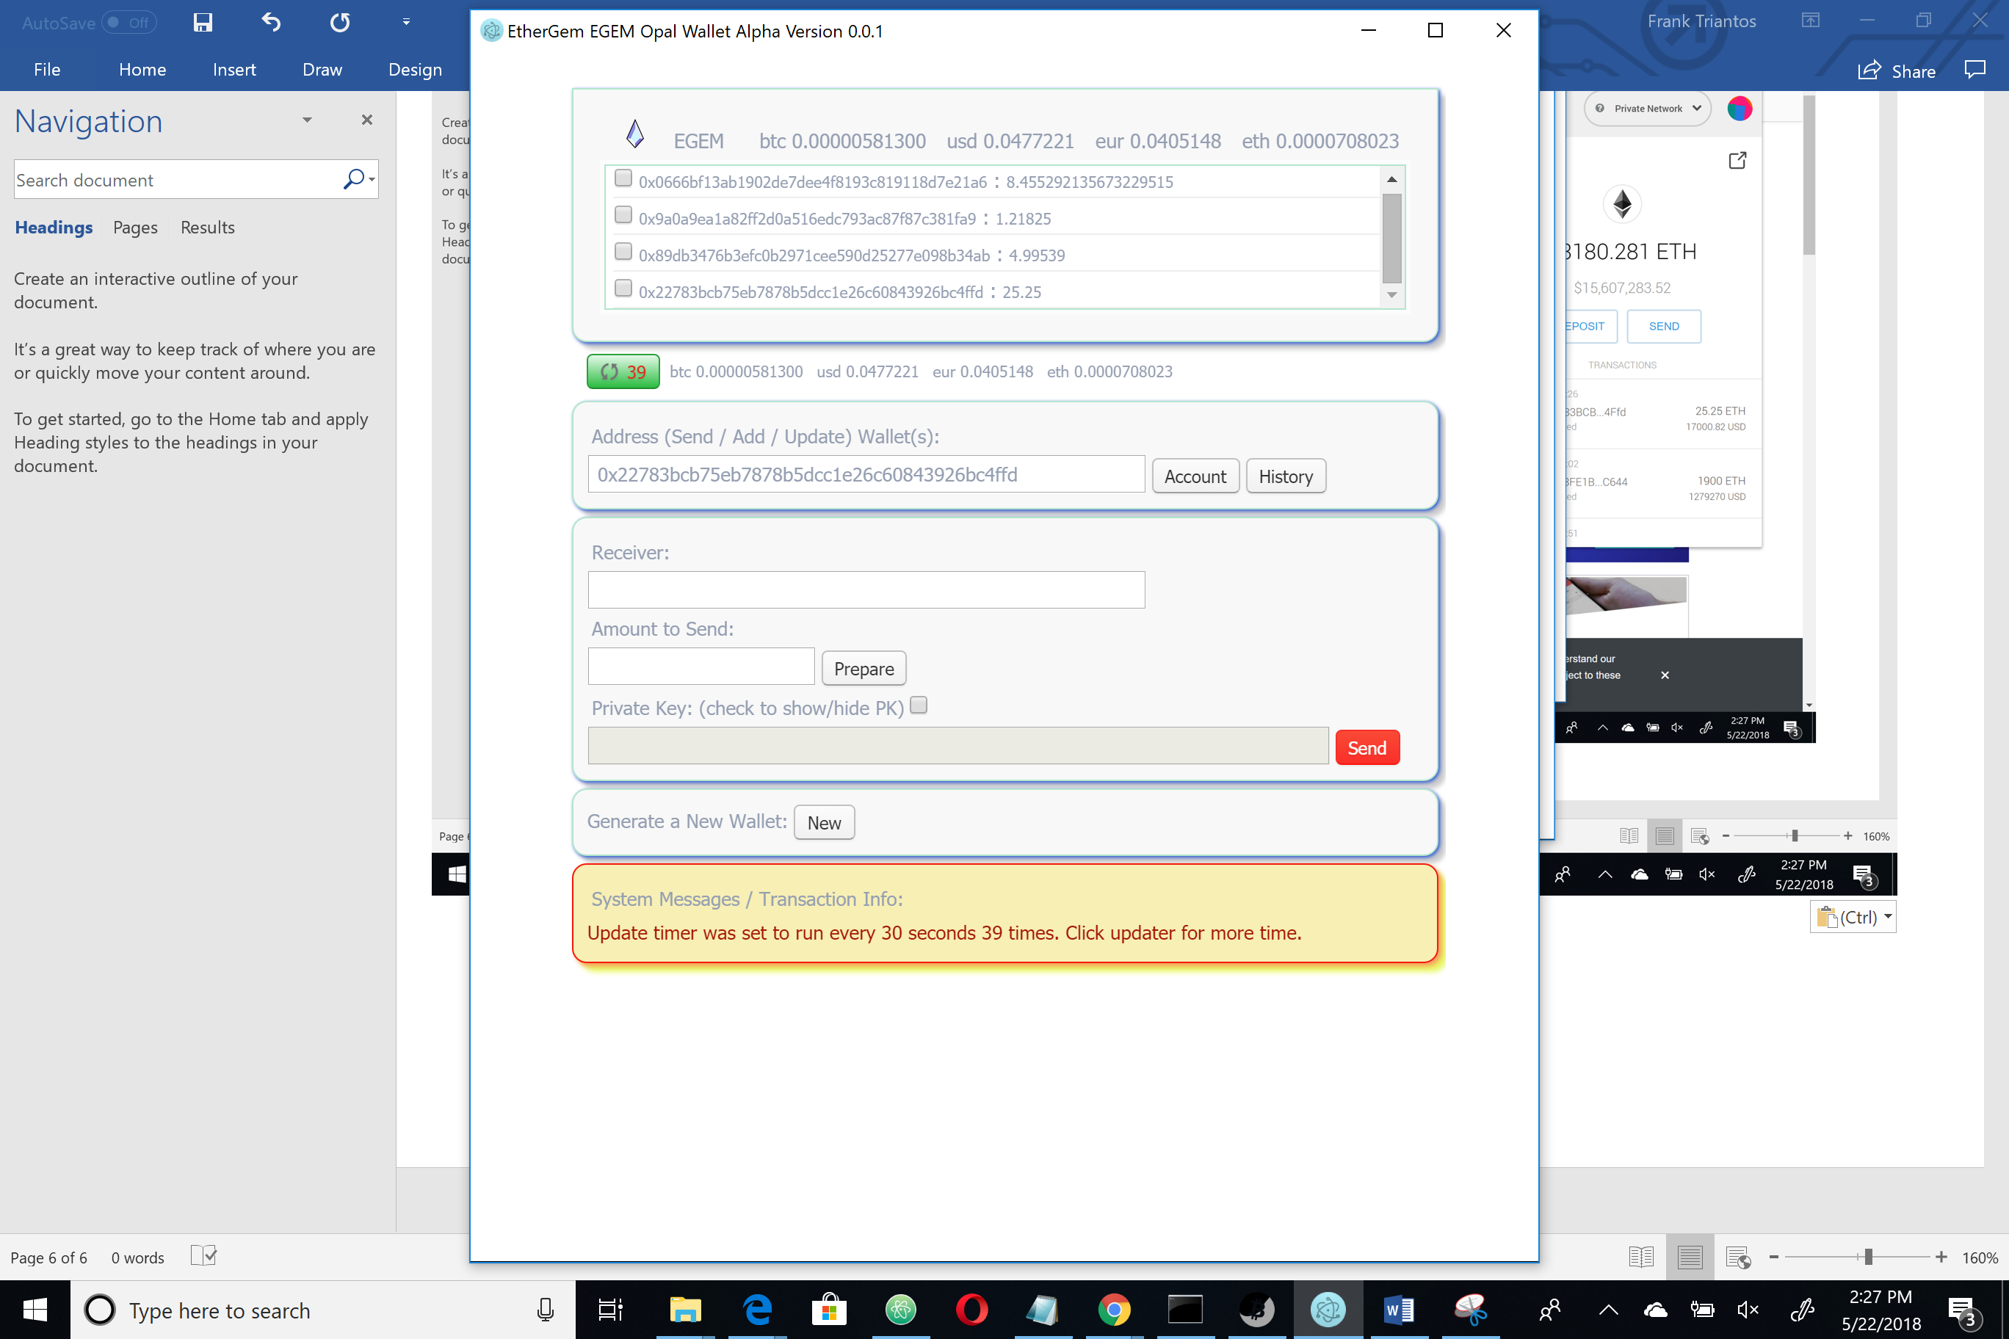

Okay, the send address and receive address are both loaded now and I have chosen to send 25 egem from the address I created with the wallet to myself from myself and because I corrupted it by giving out the private key in this document. There are other books out there that will tell you NEVER send crypto to the published addresses in the book. In this case, if you feel like doing that – just know everyone reading this is gonna check it once in a while and get a freebie. If that’s your thing and you feel like donating to that easter egg – by all means. But you also know you have the private key for that wallet yourself so you can even play chicken with the funds…lol. Seriously don’t send money there unless you just want to lose it. There are people with auto wallet functions that will have that thing set to auto send right away. You will lose your funds.

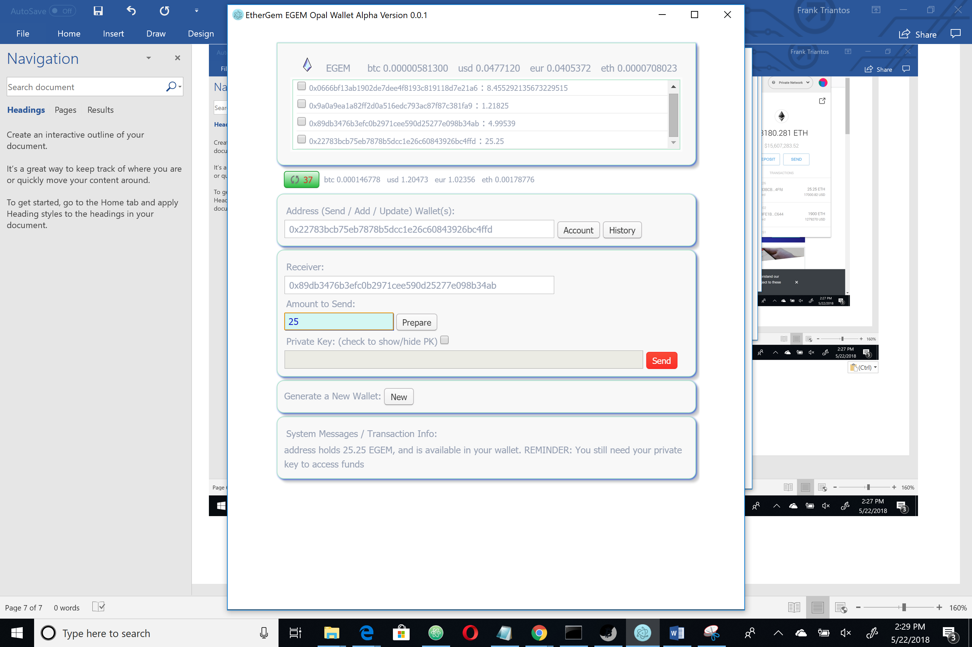

I click prepare once and the PK is enabled to load my private key:

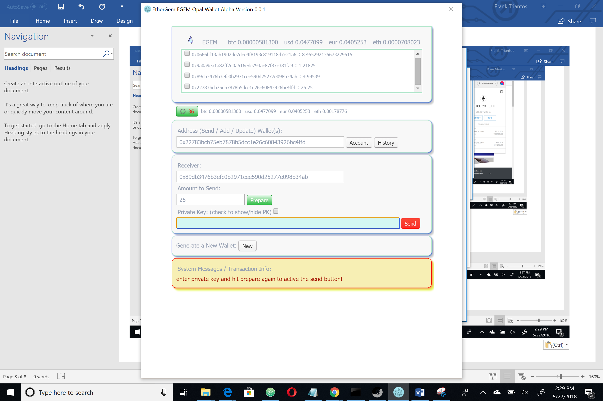

Which I copy from that text file we saved earlier (remember a real crypto OG has this offline and is very careful with it)

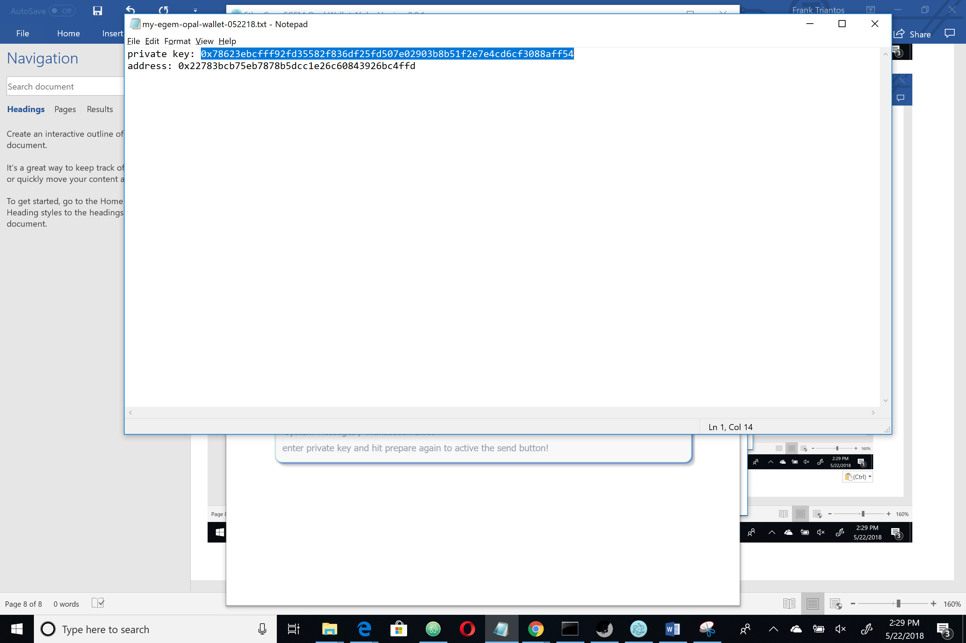

Now, we have pasted our PK into the password enabled field.

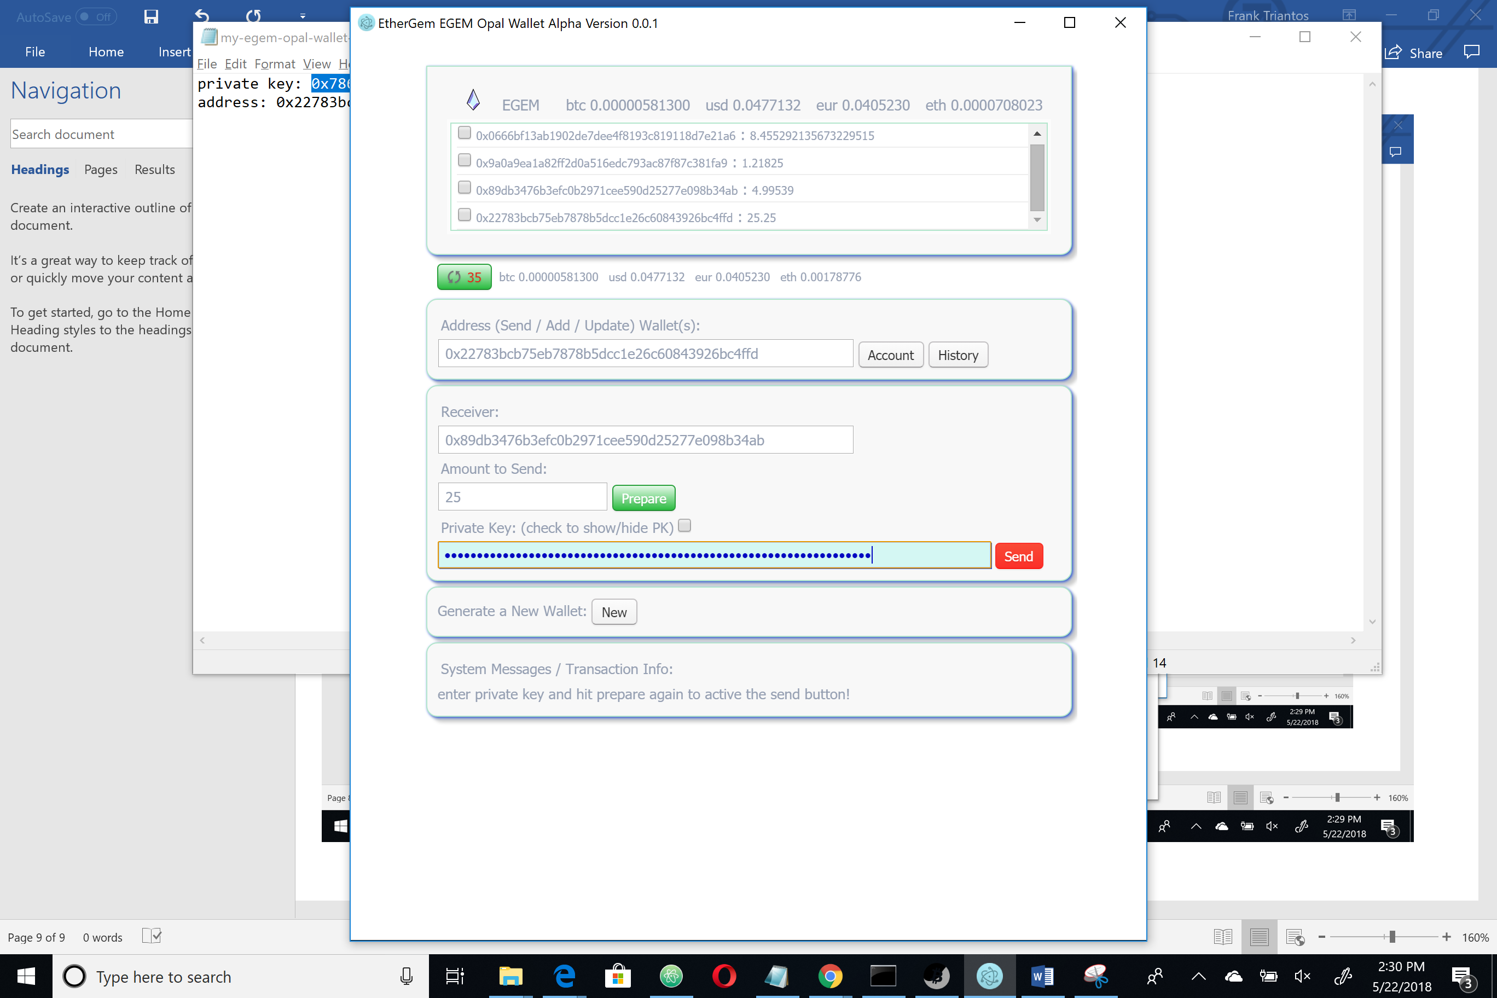

But, for some reason we feel the need to see it to make sure its right…we can do that by checking the box….

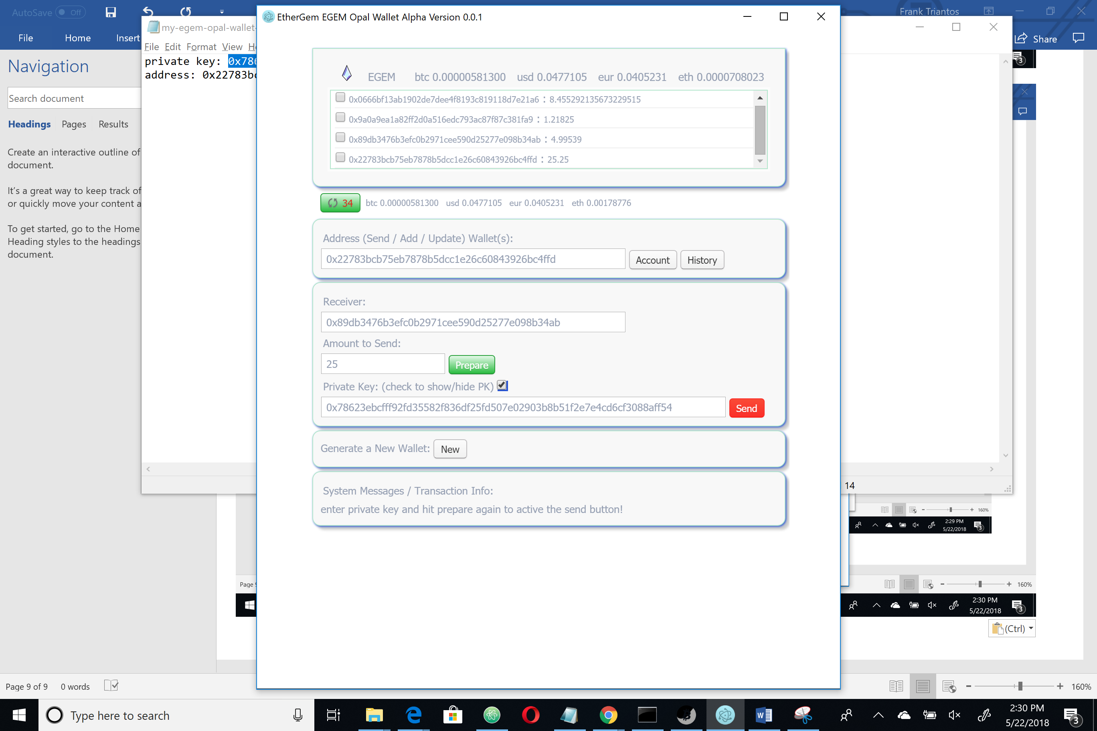

I unchecked that box because it was correct and then I hit prepare again. This time I see a nice message stating that my tx is ready to be broadcast. Everything up to this point is offline as far as the transaction goes. Look at our timer – that is online – but it is not related. And it is down to 33 now. My send button is activated (it turned green) …woah!!

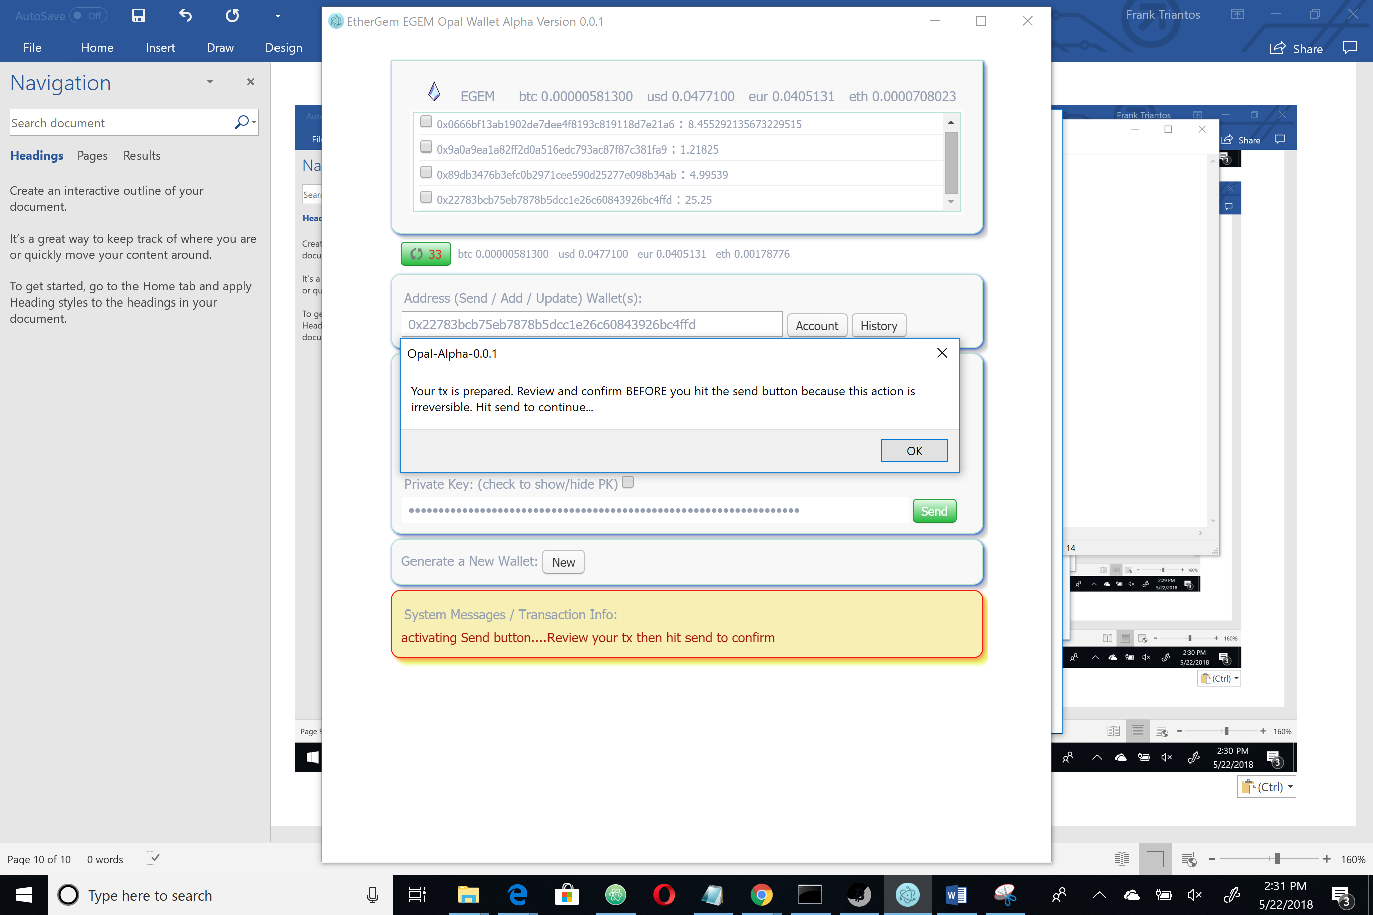

I review it for a few moments just to make sure everything looks good and

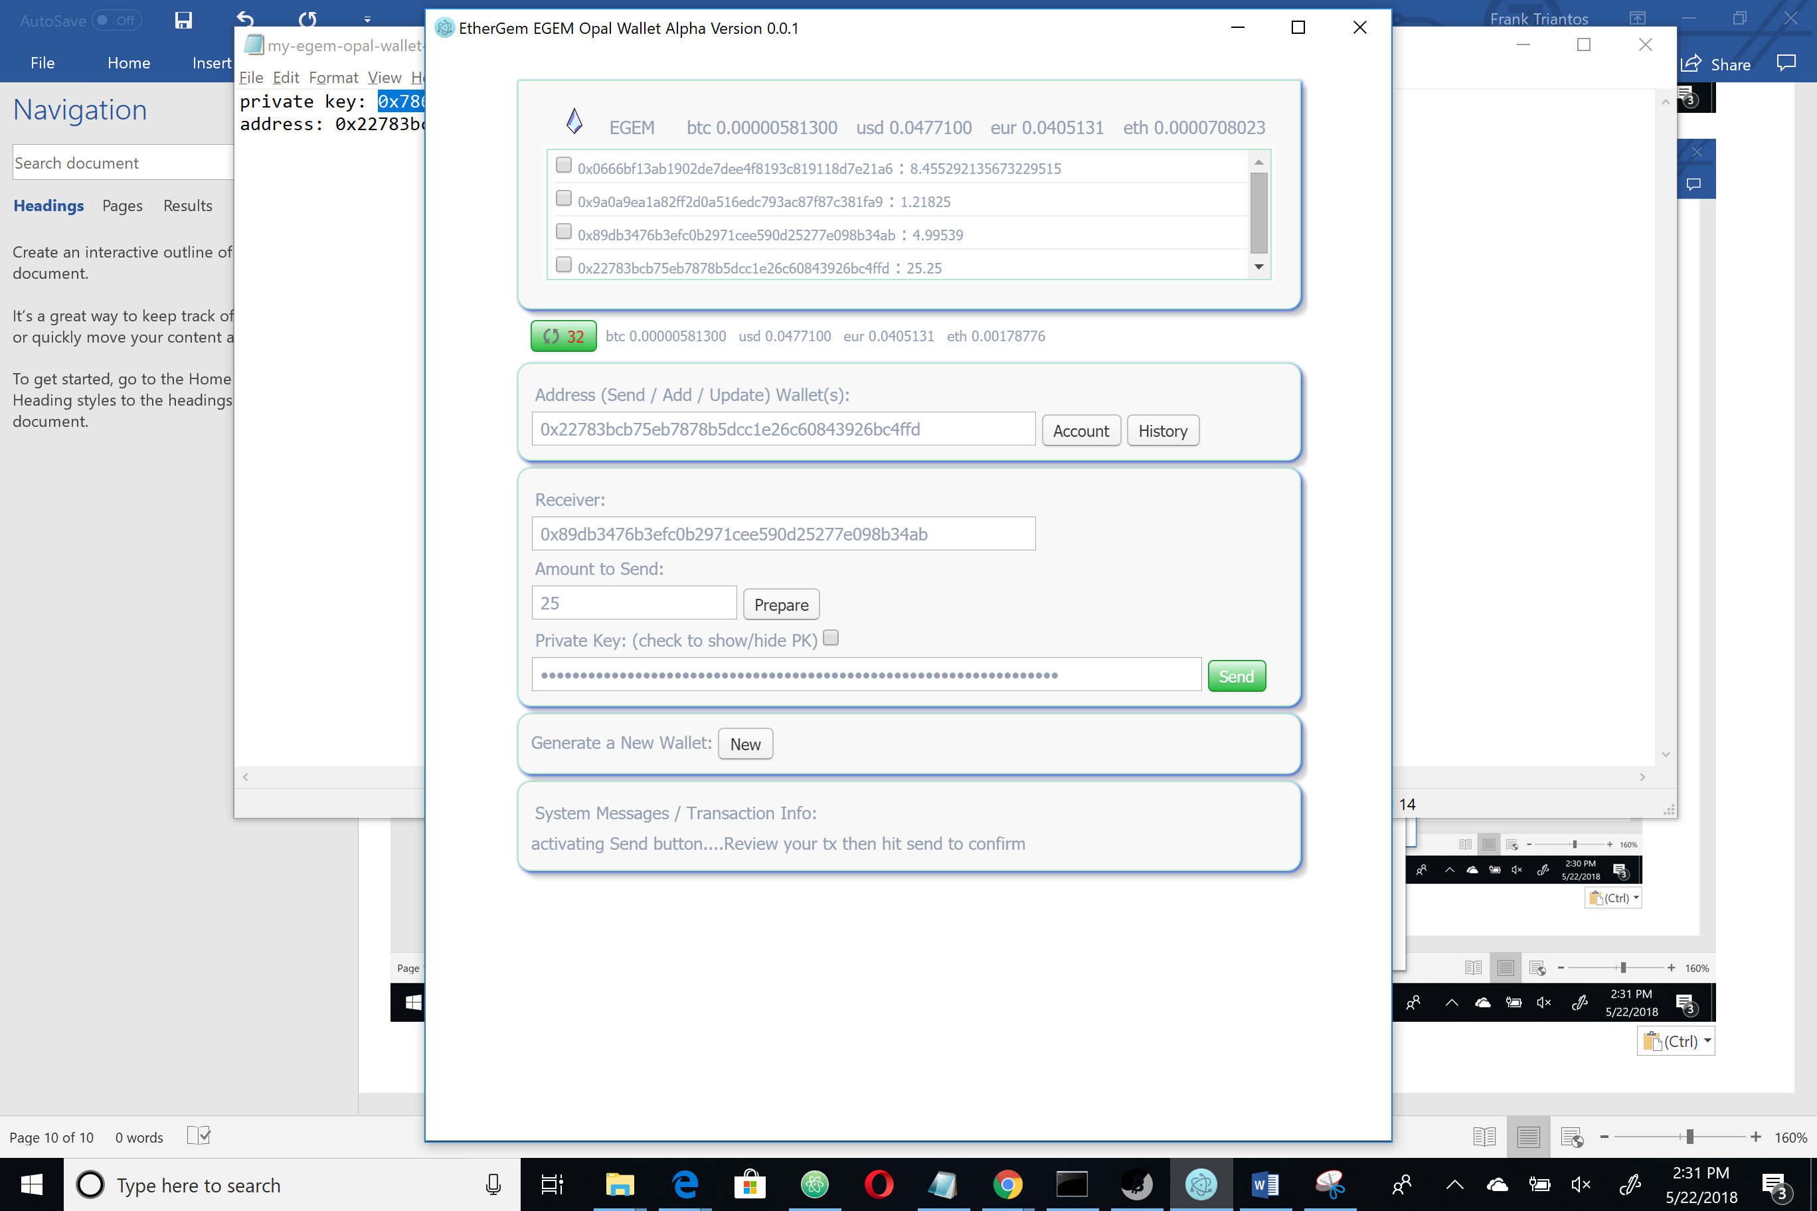

I hit send. A pop up to confirm. Please note if you cancel at this moment it will not send and you can just close out and leave the app. You have this one last chance not to send your EGEM…

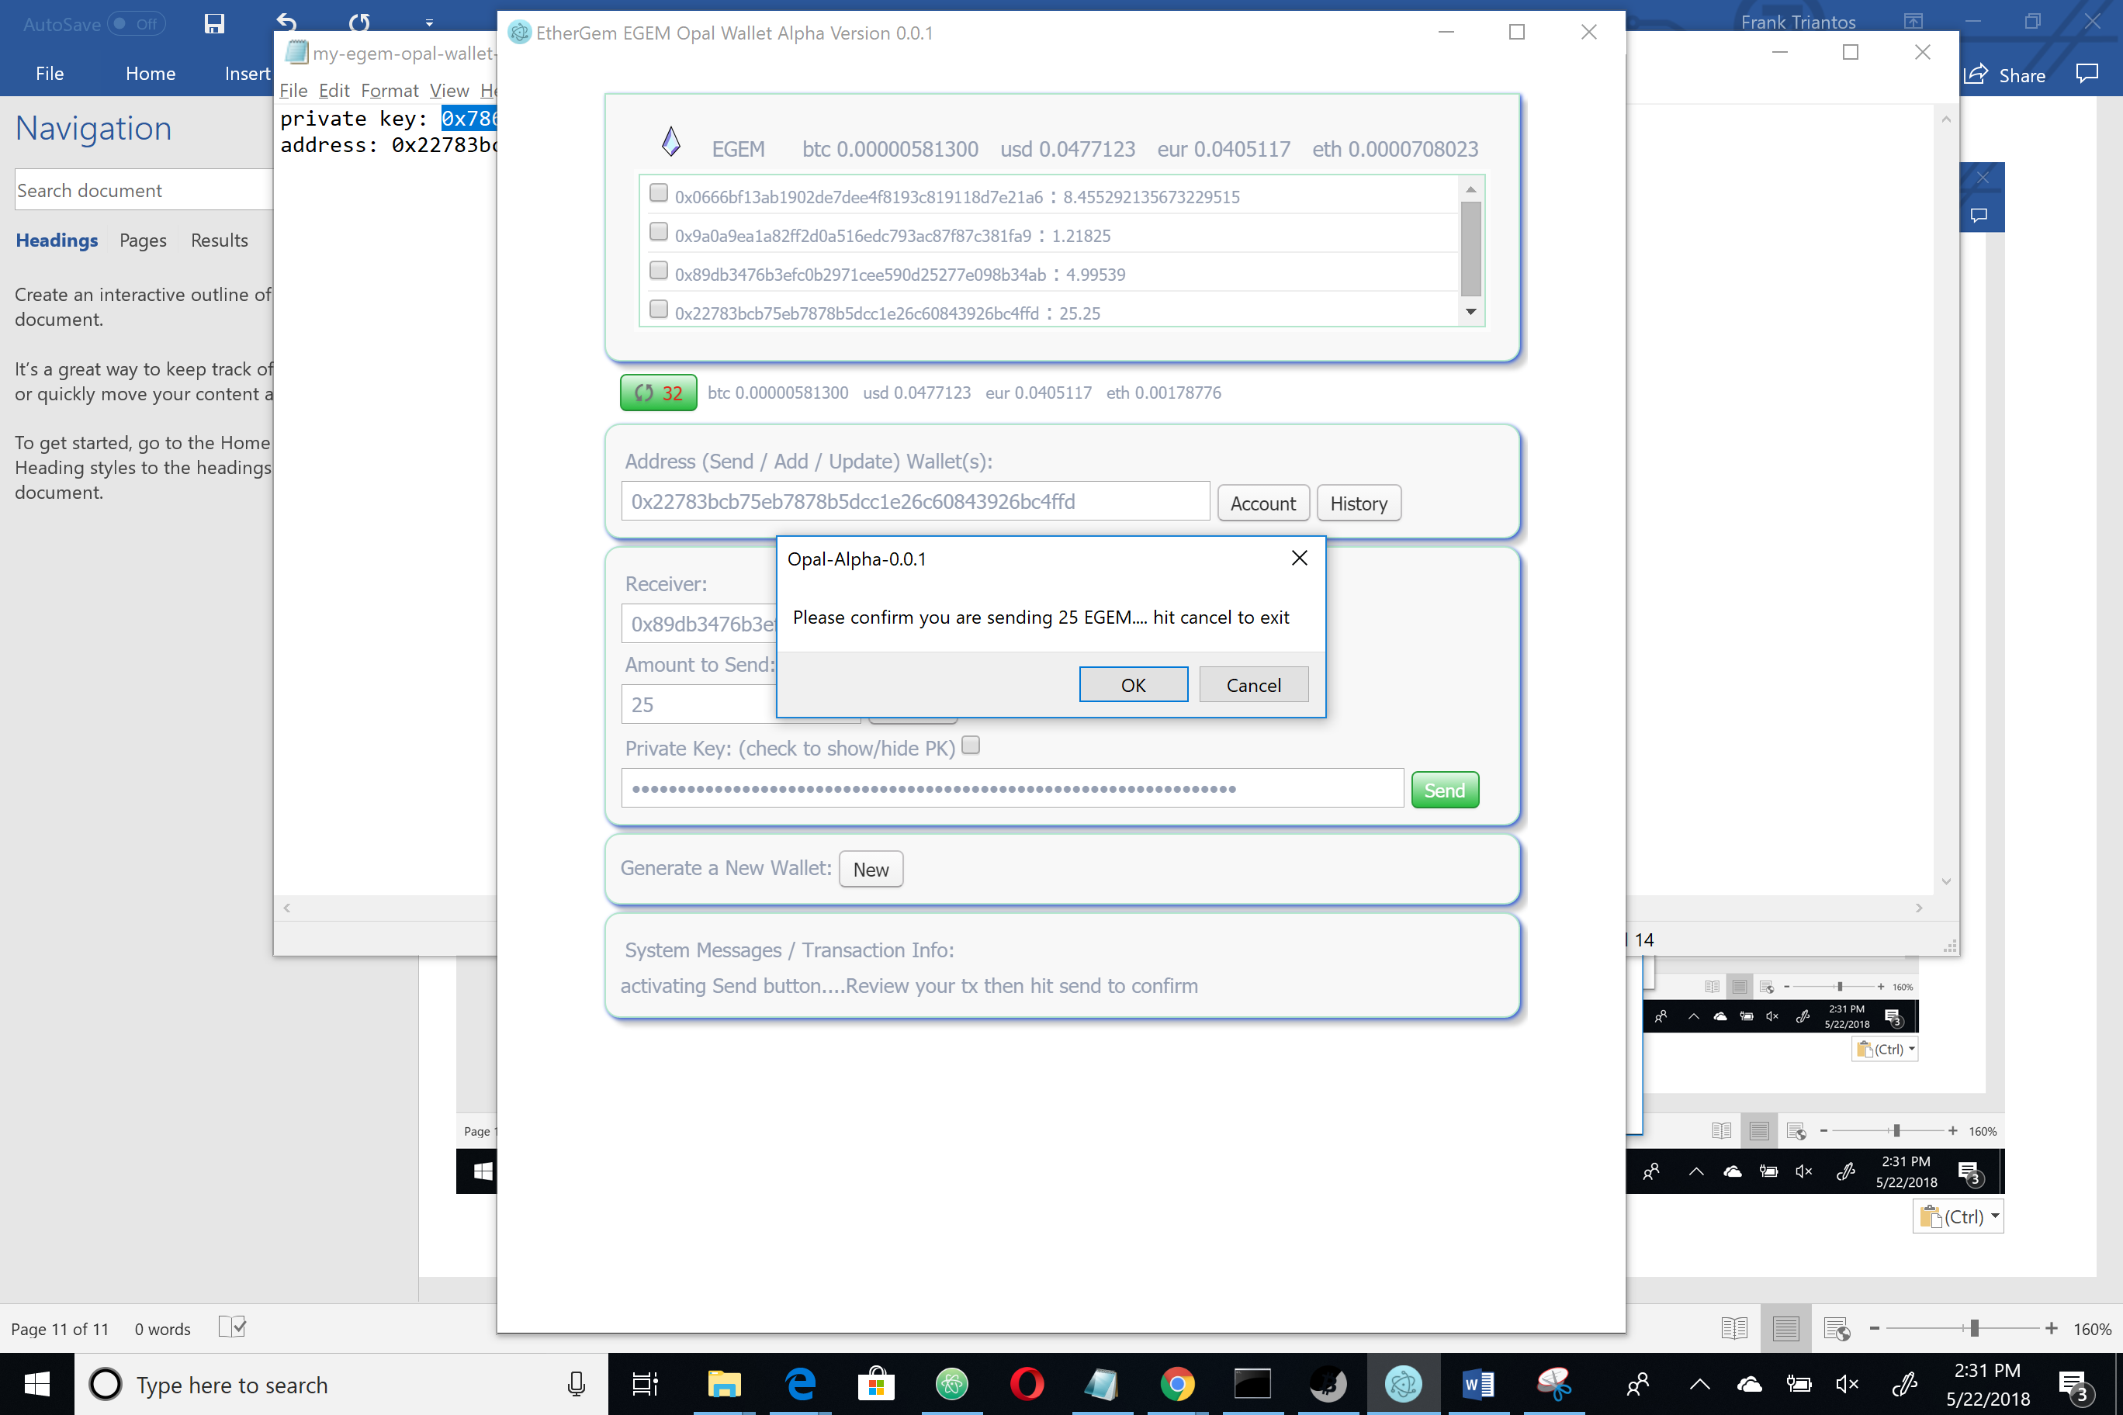

But I want to send them and kill off that wallet so…..

Sending (I hit the botton). And get a confirmation on the bottom in system messages.

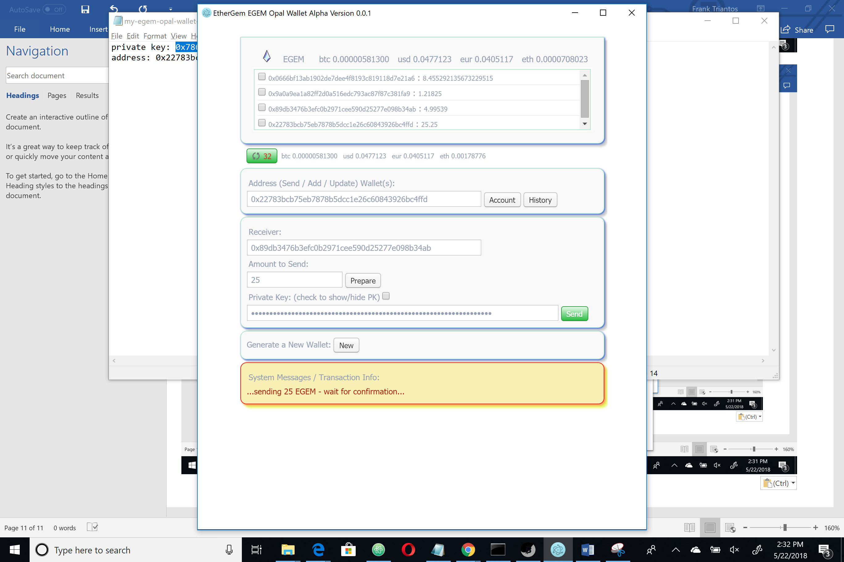

Don’t get impatient here. The screen will go back to the regular colors and the app will look like nothing is happening. If you had the console open (dev tools) you can watch the tx and messaging send to the chain but if you didn’t do that just wait. In a future release I will put a spinny and some messages. Just right now they are in the background…it should take about 30 blocks to post.

And then you will get a nice confitmation message that you can click to get to the explorer and confirm your transaction.

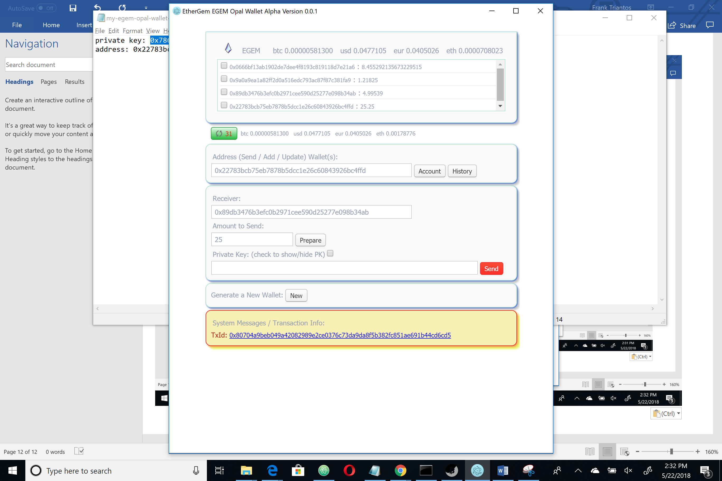

Woot! I can see my 25 egem were sent!

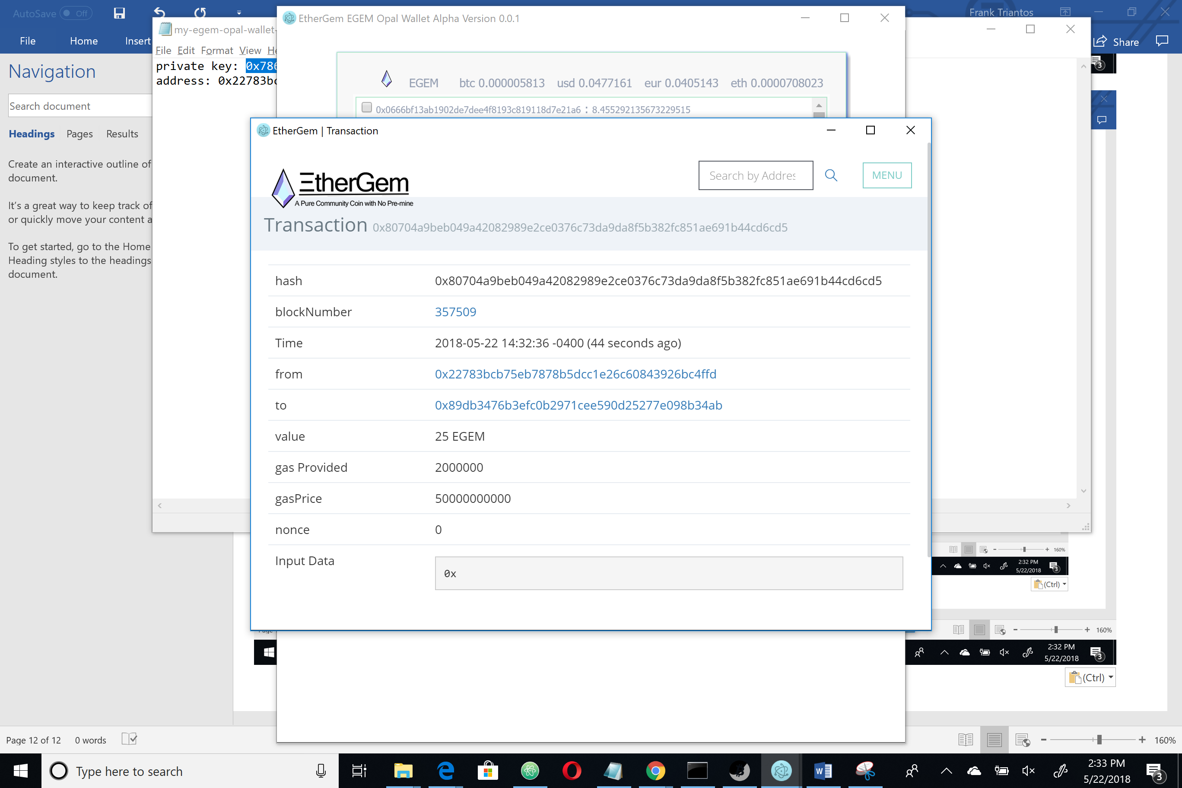

And when the timer ticks past the next 30 seconds my account balances are updated in the store.

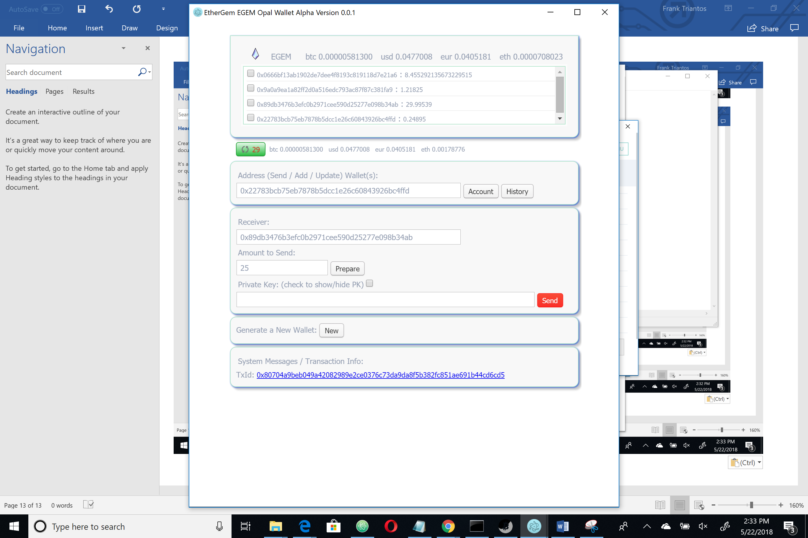

You can also grab a TX history by clicking an address in the story and the history button

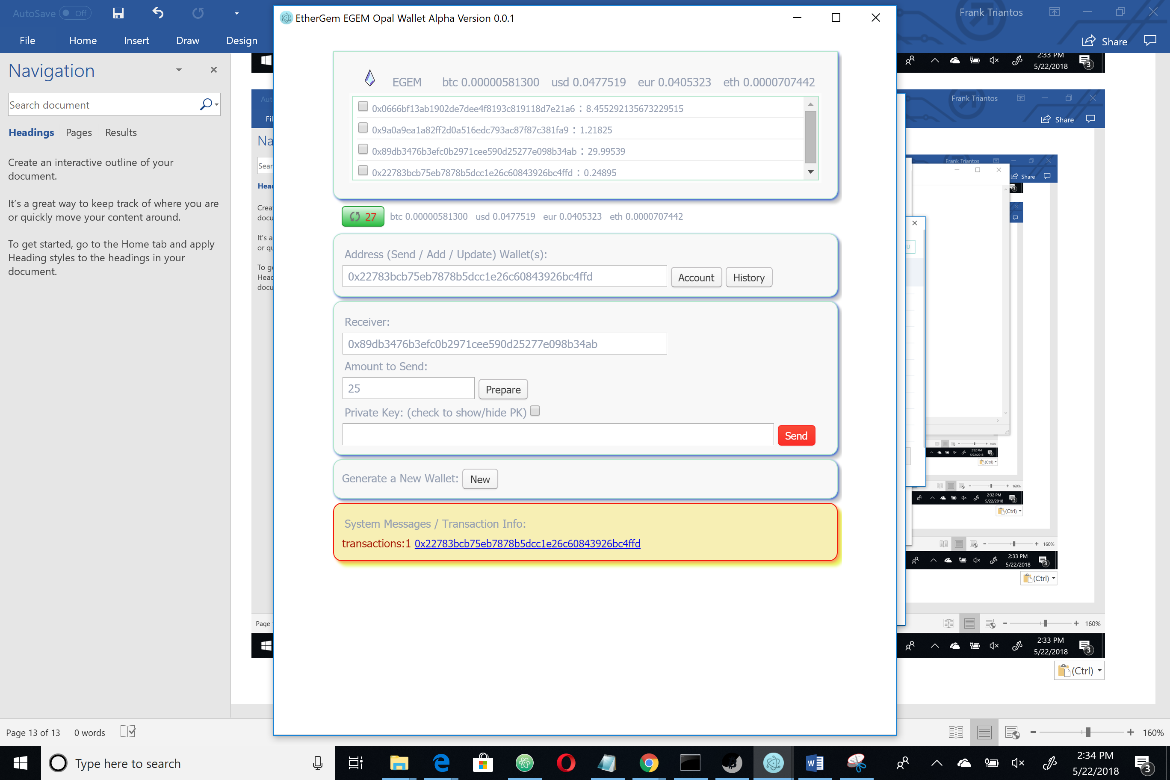

It hyper links to the explorer also… look, Ma! There is my remaining balance in this burner wallet.

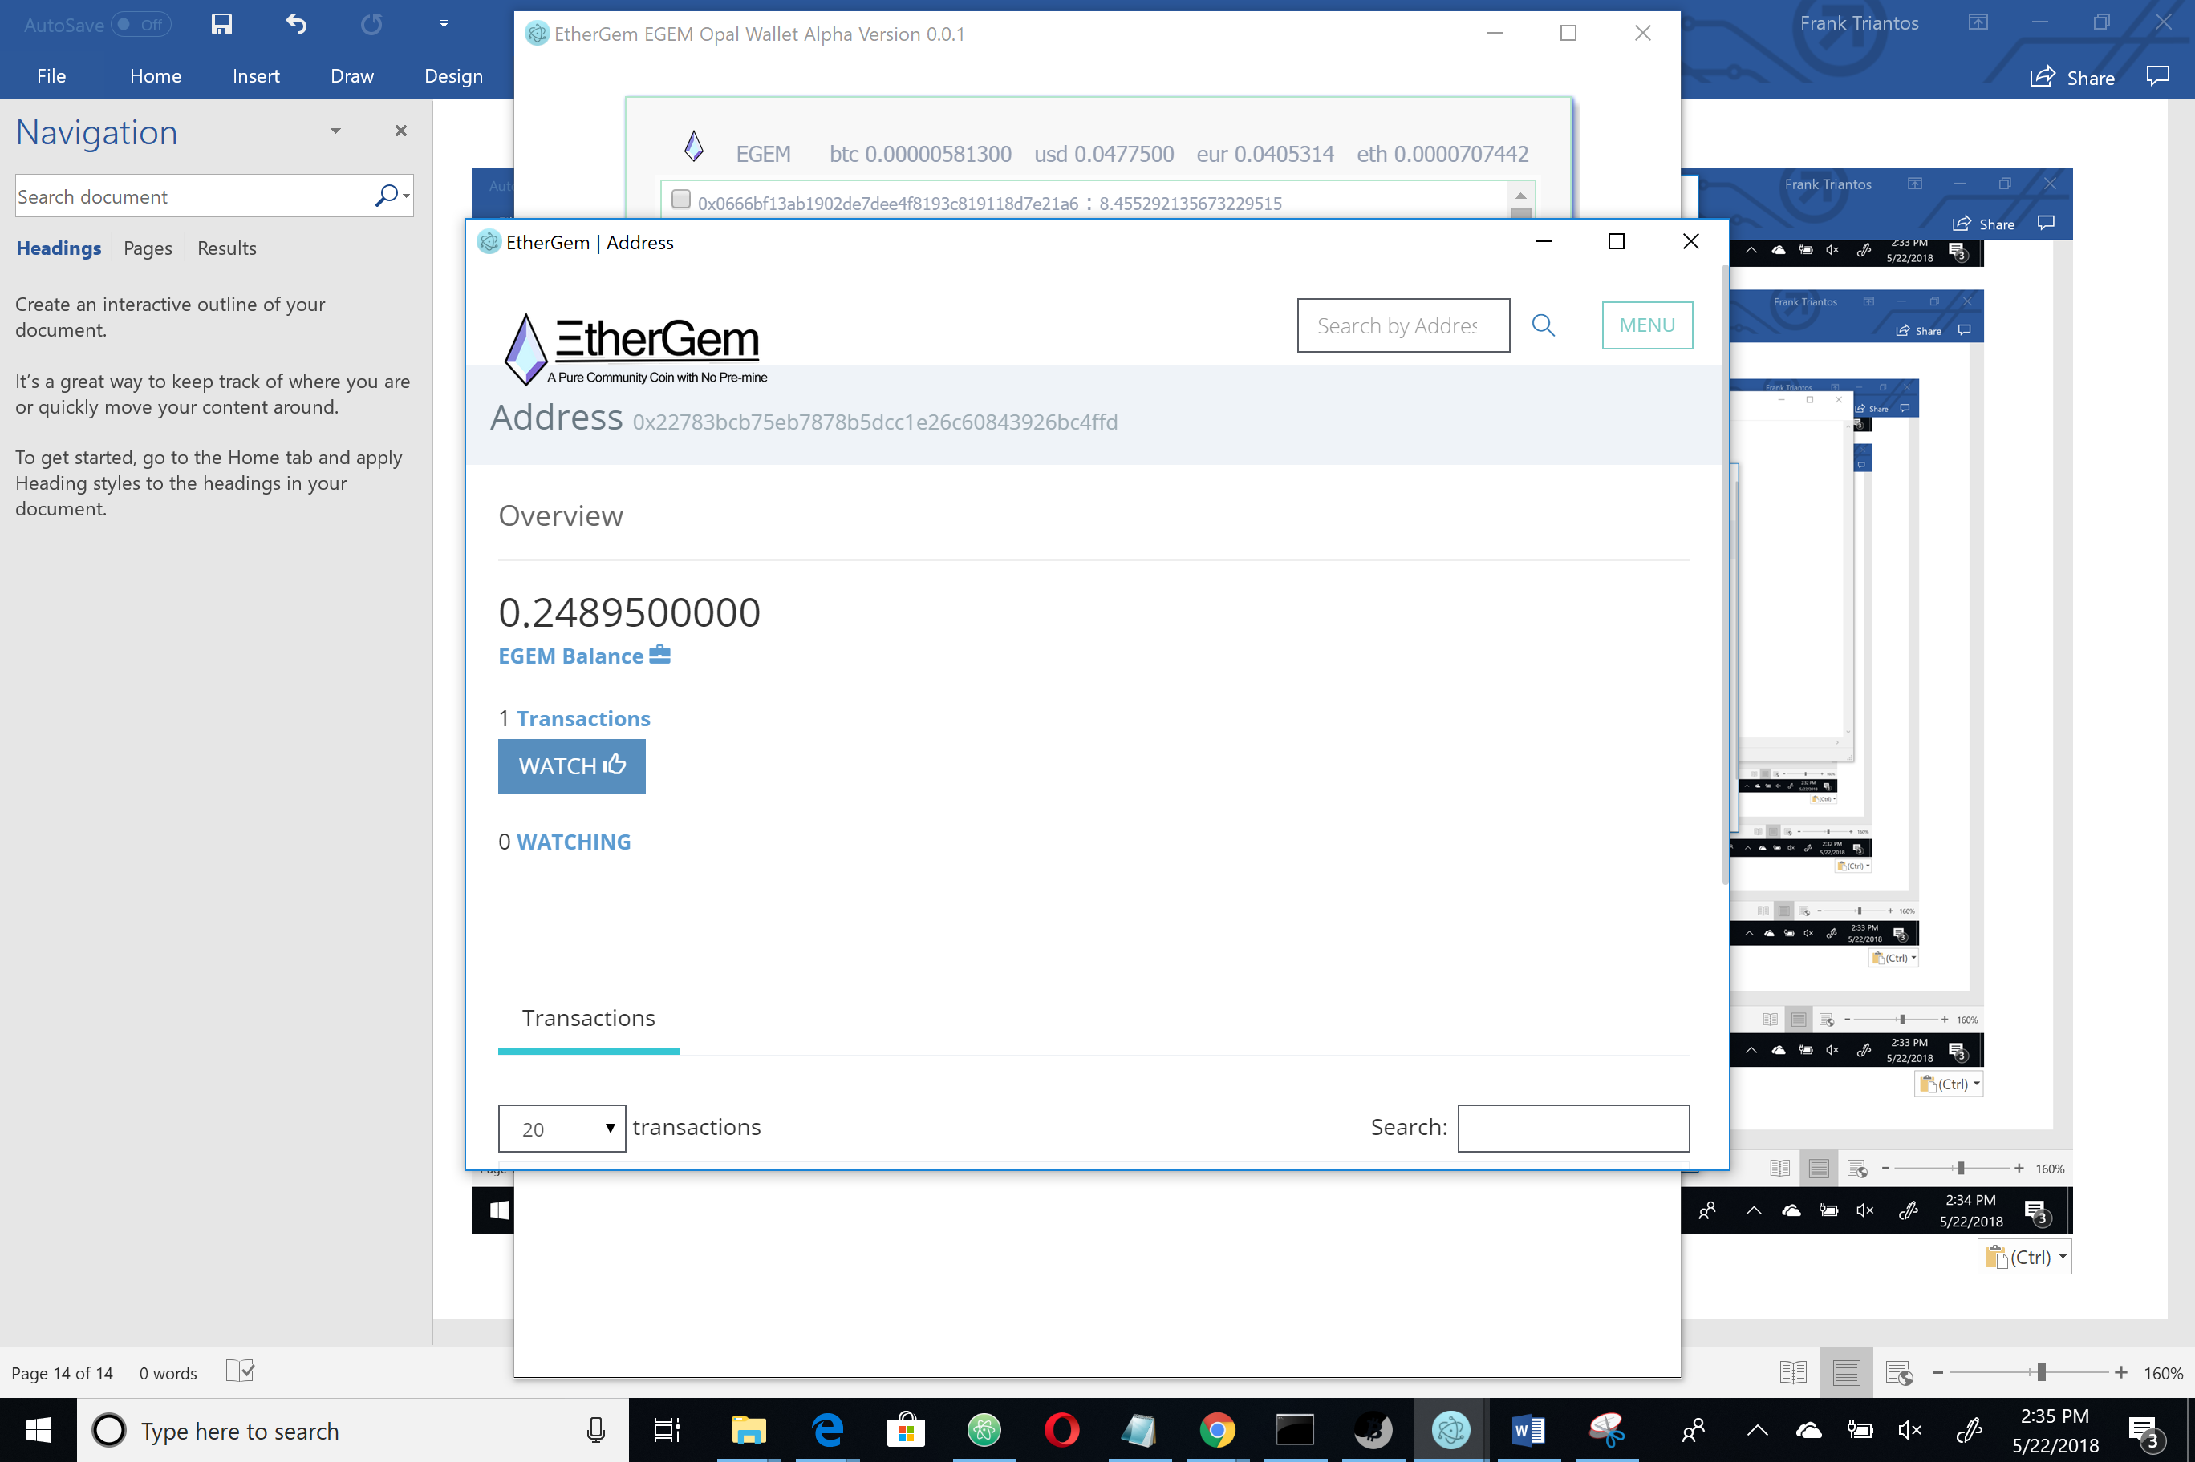

And I can scroll down and see the 2 transactions – the one where I loaded 25 egem into the wallet and the one where I sent it out.

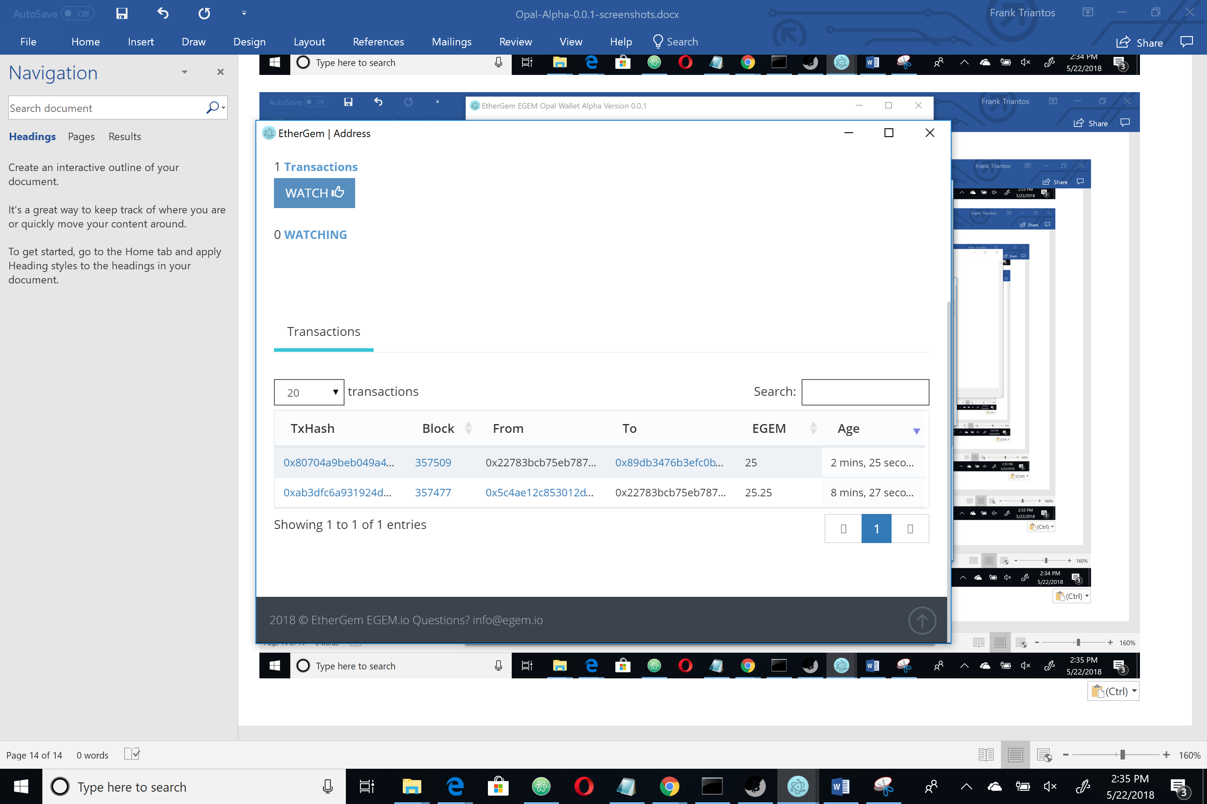

Other features like deleting wallets out of the store exist (don’t worry you can add them right back in)

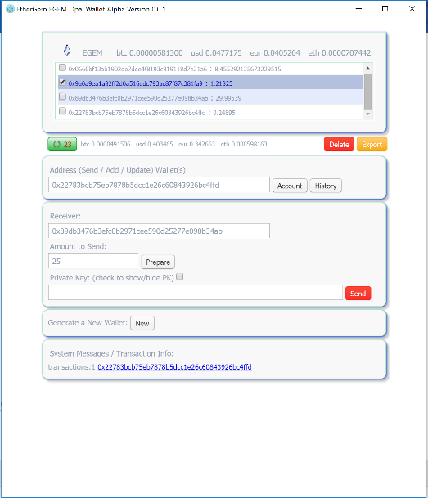

And that is all for our walkthrough of the EGEM Opal Wallet Alpha Release.